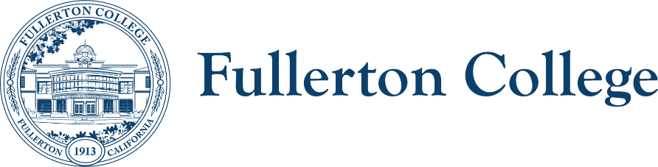
Program Review and Planning Committee
Co-Chairs: Daniel Berumen and Mary Bogan
https://committees.fullcoll.edu/program-review/
Meetings 2nd and 4th Thursdays, 3pm in Bldg.1400 Rm.1426

Program Review & Planning Committee Notes 05/14/2026
Attendees:
Co-Chairs: Daniel Berumen and Mary Bogan
Faculty Representatives: Adriana Sanchez (Humanities), Jill Kageyama (LLRISPS), Rachel Nevarez (Tech & Engineering), David Francisco Lopez (Fine Arts), Josh Ashenmiller (Social Sciences), Olivia Barajas (Counseling), Dale Craig (Business & CIS), Marcia Foster (PE), Christopher Persichilli (Natural Sciences), Luciano Rodriguez (Math & Computer Science)
Classified Representatives: Tina Maertens, Sara Camacho, (Vacant), (Vacant)
Management Representatives: Sam Foster, Deniz Fierro, Jessica Johnson, and Kristine Nikkhoo
Resource Members: Henry Hua, Sonia de la Torre, Bridget Kominek
Student Representatives: Ashton Seib

Absent: Luciano Rodriguez, Jeanette Rodriguez, Chris Persichelli, Marcia Foster, Sam Foster, Kristine Nikkhoo, Adriana Sanchez, Henry Hua, Sonia De La Torre, Bridget Kominek, Ashton Seib
MAIN AGENDA
TIME | TOPIC | ACTION & NOTES
3pm | Call to order, approval of the agenda, approval of the notes | - Approval of previous meeting notes from 4/23/26  - The committee unanimously approved the meeting notes.
3:05-3:10pm | Public comments | - None
3:10pm-3:20pm | Co-chair report: Daniel and Mary | - May 28th Meeting: Pour Company (136 W Wilshire Ave, Fullerton, CA 92832)  - Membership Updates  - Olivia’s current term is ending, and her name will need to be placed on the next Faculty Senate ballot for approval for Fall 2026.  - Report to PAC/Senate  - Daniel provided a brief presentation on Program Review updates for Fall 2026. Program review training will be held over the summer and at the beginning of the fall semester. The presentation also included a summary of the committee’s spring work reviewing instructional program reviews, including recurring themes identified across programs.  - The committee discussed the importance of developing a marketing plan, as marketing and promotional needs emerged as a common theme in the program reviews. Some faculty expressed concerns about lacking sufficient time to effectively market their programs. Programs also shared concerns regarding declining enrollment and the lack of college-wide marketing and outreach strategies. Committee members noted that these concerns have been recurring themes over several years.  - Reader Reports will be delivered to deans and program review writers before the May 21st Faculty Senate meeting  - Reader reports and instructions for the Fall 2026 annual updates will be distributed via email within the next couple of weeks.  - Questions for the Student Services and Administrative Operations departments will be shared in June.  - The committee will begin discussions in the fall regarding potential changes to the program review timeline and process.
3:20pm-  3:40 pm | Finalize Student Support Services Questions | Finalize Student Support Services questions for Fall 2026  - Student Support Services expressed interest in changing the term “Strategic Action Plan” to “Goals.” Daniel is currently working with the ACT department to determine whether this change can be implemented in the new form. The committee approved the request to use the term “Goals.”
3:40pm-4:20pm | Finalize Administrative & Operational Department Questions | Finalize Administrative and Operational Departments for Fall 2026  - The committee reviewed the questions and made minor revisions.  - During the virtual training, the co-chairs will emphasize in Section 2, Question 1, that departments are not required to list every individual employed within their department.  - The committee also discussed the new accreditation standards related to self-assessments in Section 4, Question 1, and proposed adding a brief note to clarify that the question is tied to accreditation requirements.  - The committee approved the final version of the questions.
4:20pm-4:30pm | Instructional Annual Update Fall 2026 | Identify what we want to ask Instructional programs in Fall 2026  - Update SAP Status (New, In Progress, Dropped/No longer doing)  - SLO Data (If available)  - New SAPS  - New operational requests  - Fixes/Incompletes from Fall 2025 version  The document containing the questions will be distributed in advance, and the form will be available in the fall semester.  The committee also decided to extend the due date for Student Support Services and Administrative Operations program reviews to approximately January 15.

RESOURCES
Upcoming Meetings: 5/28

