Annual SLOAC Summary Report for the year 2024-2025 (Presented by George Bonnand)

Summary Report (as of 4-12-25) (Note: Student Learning Outcomes | Fullerton College (fullcoll.edu))
The following is a summary of the items that the SLOAC committee has done over the past 2024-25 academic year.
- SLOAC members meet regularly during the academic year to address Course Student Learning Outcomes (CSLOs) and Program Student Learning Outcomes (PSLOs) issues as well as Elumen issues that faculty have. There are eleven members plus one student representative on the SLOAC and one chairperson.
- The SLOA Committee has assisted with ACCJC Accreditation information/data research. As additional course data or program data is needed from Elumen, reports will be provided as best as possible by the SLOAC chairperson or designee.
- Review and updating of CSLOs each semester is an ongoing manual process performed by all members of the committee. At this time all courses have CSLOs attached to them. However, there are 774 CSLOs of 3915 courses that have unmapped CSLOs. There are also 149 CSLOS of 3915 courses that do not have an assessment associated with them (See Figure 1).
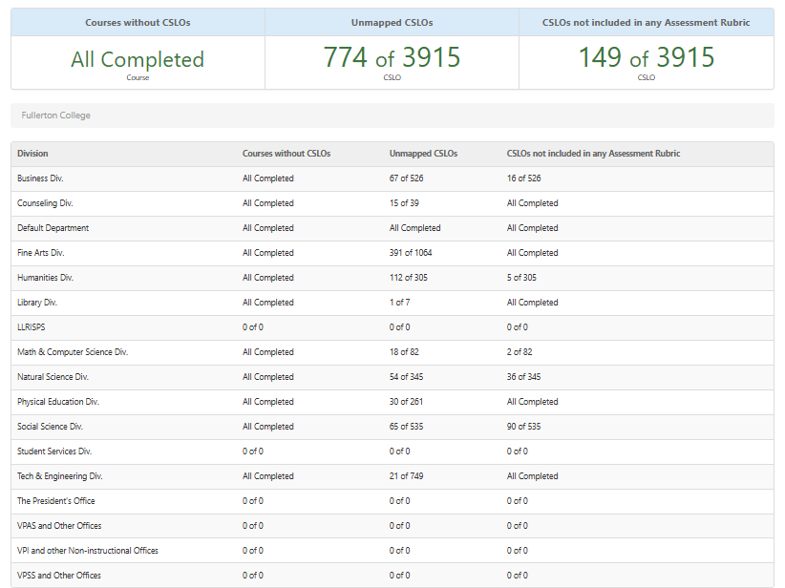
Figure 1 (as of 4-12-25)

- Review and updating of mapping of CSLOs to PSLOs is an on-going process in the Elumen system since new courses are created, approved, and then loaded into Elumen via a download from Banner. Review and updating of mapping of CSLOs to PSLOs and then PSLOs to ISLOs is an ongoing manual process performed by all members of the committee.
- There are 322 of 901 PSLOs that are not mapped to ISLOs. There are 131 of 901 PSLOs that are not mapped to CSLOs. There are 730 of 901 PSLOs that do not have any assessment rubric associated with them (See Figure 2). (Please note that PSLOs do not need to be assessed independently (necessarily) if they are mapped to a CSLOs.)
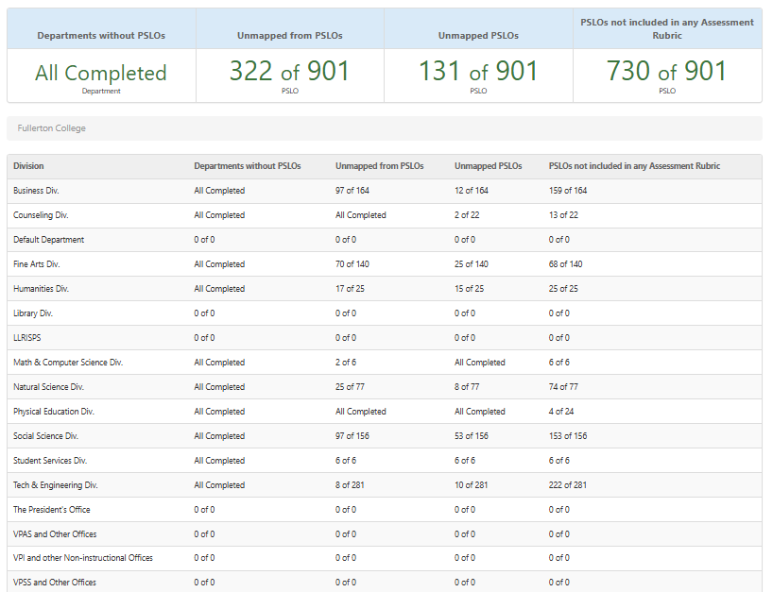
Figure 2 (as of 4-12-25)

- All ISLOs are typically mapped to at least one PSLO (See Figure 3 and 4). At this time, all ISLOs have been mapped to by at least one PSLO. Note: In Elumen the mapping of one set of SLOs to another set of SLOs of a higher scope is done through our matrix. These mappings drive the aggregation of data results.
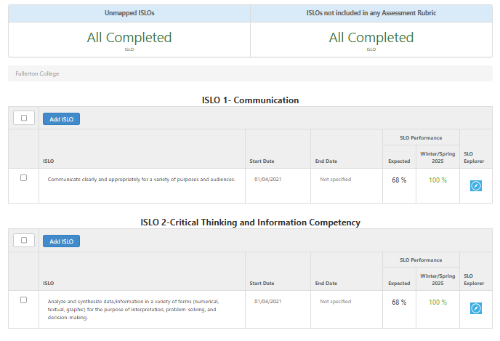
Figure 3 (as of 4-12-25)
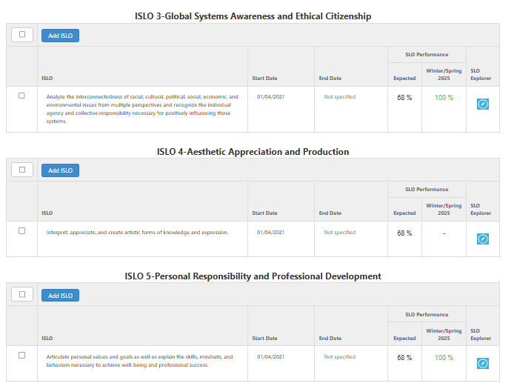
Figure 4 (as of 4-12-25)
Other SLOAC Action Items that are either complete or in process for 2024-25 academic year.
- SLO website has been updated/revised as of March 2025.
- Transition from Elumen to Insights is in process. As some folks may or may not be aware we are in the process of transitioning from Elumen to Insights (which is part of the Canvas product). Tentative implementation is Fall 2025. This transitioning project started in May of 2024 since Elumen corporate announced that this Elumen product will commence sundowning operations this year. The faculty senate and the VPI were notified and approved the transition of Elumen to Insights in May of 2024. The yearly cost of this is the same as the cost for Elumen hence the yearly renewal contract included this option which was signed. It is our hope that the faculty will like this product since many of the software ancillary items associated with Insights are found directly in the Canvas product today and are used by our faculty. Insights will add the element of year-to-year data review and disaggregated data. Insights is also compatible (partnered with) with “Coursedog” and many other curriculum software products.

Note: I have attached a separate document showing the members of the SLOAC for 2024-2025 academic year.

