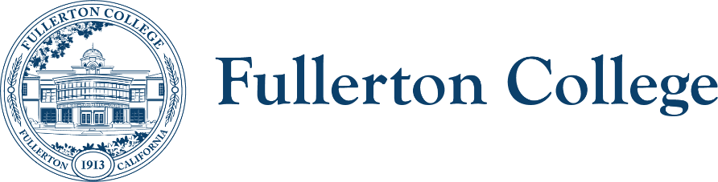
Diversity Advisory Committee
ZOOM: link
Meeting Lead: Connie Moreno Yamashiro
May 6, 2026

Diversity Advisory Committee Meeting Agenda
Purpose:
The mission of the Campus Advisory Committee is to work with the campus community to develop, recommend, and assess appropriate policies, programs and strategies to achieve a diverse, inclusive and just campus.
The committee is responsible for making recommendations to the President’s Advisory Council on diversity issues that affect the experiences of all members of the Fullerton College community.

In order to facilitate our work together, we agree to the following commitments:
- Commit to open, honest and constructive dialogue.  - Listen to the perspectives of others and seek understanding.  - Create and maintain a culture of trust, honesty, support and confidentiality.  - Respect each other's lived experiences, perspectives and ideas.  - Prioritize projects that are in the best interest of the Fullerton College community through the lens of Access, Community and Learning. | - Collaborate on shared goals with a growth mindset for continuous improvement.  - Be present, engaged and prepared.  - Following the meeting, speak positively and support the work of the team.  - Have fun.

Outcomes:
- Work on 25/26 academic year goals
WELCOME ACTIVITY

FOLLOW UP ITEMS – 10 min.
- N/A

MAIN AGENDA
TIME | TOPIC | PRESENTER | PURPOSE | ACTION
10 Min. | Review of April’s meeting notes | E. Lindley |  | Voting item
15 Min | Road Show Sign up | E. Lindley
15 Min. | Co-Chair Nominations | All
20 Min. | Committee Composition | All
10 Min. | 25/26 Annual Report | All
10 Min. | Announcements: | All
RESOURCES
Approval Process for DAC Recommendations SP26.xlsx
2025-2026 Diversity Advisory Committee Year End Summary1.docx

Next meeting: Wednesday, February 3rd, 2026 from 3:00PM – 4:30PM

