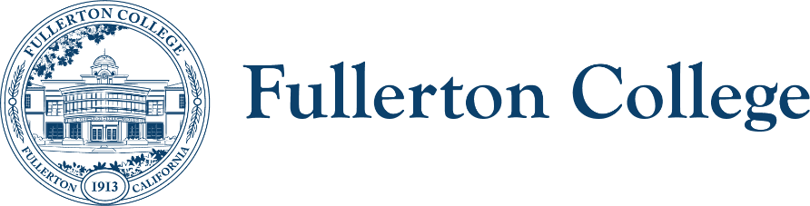
Campus Collaboration Committee Notes

Co-Chairs: Daniel Berumen, Bridget Kominek
Members: Jennifer Merchant, Jeanne Costello, Bridget Kominek, Mary Bogan, Ericka Adakai, Anita Juarez, Ziza Delgado, Darnell Kemp, Michael Mangan, Evelyn Lindley, Connie Moreno-Yamashiro, Jorge Arrendondo, Roman De Jesus, John Ison, Tam Contreras, Valerie Salazar, Curtis Galvez, Cecilia Arriaza, Albert Abutin, Garrett Campbell, Kim Vandervort, Annika Shellenbarger, Porsha Boyd, Miranda Bates, Marietta Gilliard, Johnathon Krok, Theresa Ullrich, Henry Hua, Jodi Balma, George Bonnand, Cynthia Guardado, Toni Nielson
Recorder: Bianca Gladen

HOUSEKEEPING
- Call to Order
- Review of Previous Notes
- Co-chair report
  - Meeting dates for Spring 2026: 2/3, 3/3, and 5/5
    - April meeting will be cancelled
  - Future agendas: Updates on Aspen Institute projects and updates on program review
    - The Aspen Institute is a national organization focused on improving outcomes for colleges.
    - Our college participates in the Aspen Institute’s Transfer Institute, which Cecilia is involved in.
    - Our college is also involved in the Unlocking Opportunity initiative, which focuses on helping students graduate and earn a living wage.
  - Are there suggestions for agenda items for future meetings for this semester?
    - None

TOPICS FOR DISCUSSION
- Update on proposed changes to Campus Collaborations Committee
  - A first reading of the proposed changes will occur at Faculty Senate. Implementation of the new committee structure is scheduled for Fall 2026.
- Committee/program updates. What are your group’s top priorities or projects for the Spring 2026 semester? What collaboration might be useful across areas?
  - The Program Review Committee will review Instructional program reviews during the Spring semester.
  - In May and June, Instructional programs that requested program review funds will be notified of award decisions, with approved funds included in the FY 2026–27 budget.
  - A timeline with specific dates for Student Services and Administrative/Operational program reviews will be shared soon.
  - By the May Faculty Senate and PAC meetings, recommendations for Student Services and Instructional programs will be presented. Efforts are underway to align review criteria with the Strategic Plan.
- Seal of Excelencia update—Jeanette Rodriguez
  - Jeanette Rodriguez presented information on the Seal of Excelencia, which is structured around three pillars: leadership, data, and practice. Fullerton College has a writing team consisting of Sonia, Daniel, Deniz, and Jeanette. The college has attended most of the related Institutes. Dr. Olivo has joined the Action Network, which serves as a resource for connecting with other colleges that have received the Seal of Excelencia.
  - Fullerton College began the process in Fall 2024 and plans to apply for the Seal of Excelencia in Spring 2026.
- Curriculum Updates (John Ison)
  - Course Dog: Additional information will be shared as the college moves forward with acquiring the new software.
  - CCN: The college is currently in Phase 2. The Chancellor’s Office has paused Phase 3 templates, as they will require pre-approval for articulation.

- SEAC Update
  - The SEA Plan was submitted at the end of the previous semester, and the college is now in the implementation phase, with an emphasis on goal setting and structure.
  - Fullerton College is now designated as a Black Serving Institution (BSI), as outlined in the SEA Plan. The college plans to use the same framework as the Hispanic Serving Institution (HSI), in collaboration with the North Star Committee.
- Guided Pathways Update
  - Program Mapper is currently transitioning from version 1.0 to 2.0, and most program maps are unpublished during this transition period.
    - 45 AA/AS degrees have been revised using the new AA/AS guide sheet. The remaining degrees will be revised during the Spring term and may take additional time to publish.
  - OER/ZTC: The Guided Pathways Office will place increased emphasis on accurate data collection to improve XB12 reporting. A full-scale effort using this data to support adoption of ZTC pathways is planned for Fall 2026.
    - The office is also developing an online teaching certificate for faculty focused on ZTC.
  - FYE: Every section of English, Math, and Business now includes FYE support. This semester, FYE is collaborating with Communication Studies and Ethnic Studies to develop discipline-specific first-year engagement activities. The team is also working on data collection to assess the impact on first-year students.
- Accreditation
  - Feedback for the Integrated Planning Manual will be revised this semester.
- HSI Committee has an upcoming meeting on February 3rd to further discuss collaborations regarding BSI efforts.
- Diversity Advisory Committee
  - Two subgroups will be established: one to develop recommendations for immigration-impacted communities, and another to formulate recommendations for becoming a Black-Serving Institution."

UPCOMING MEETING: March 3, 2026

