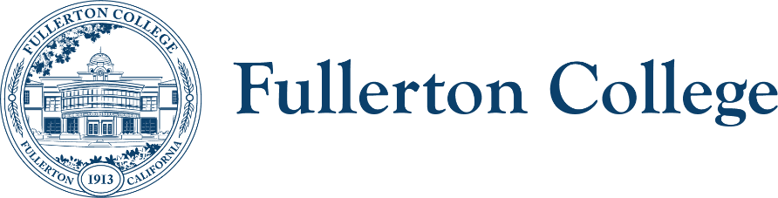
Diversity Advisory Committee
ZOOM: link
Meeting Lead: Connie Moreno Yamashiro
October 1, 2025

Diversity Advisory Committee Meeting Agenda
Purpose:
The mission of the Campus Advisory Committee is to work with the campus community to develop, recommend, and assess appropriate policies, programs and strategies to achieve a diverse, inclusive and just campus.
The committee is responsible for making recommendations to the President’s Advisory Council on diversity issues that affect the experiences of all members of the Fullerton College community.

In order to facilitate our work together, we agree to the following commitments:
- Commit to open, honest and constructive dialogue.  - Listen to the perspectives of others and seek understanding.  - Create and maintain a culture of trust, honesty, support and confidentiality.  - Respect each other's lived experiences, perspectives and ideas.  - Prioritize projects that are in the best interest of the Fullerton College community through the lens of Access, Community and Learning. | - Collaborate on shared goals with a growth mindset for continuous improvement.  - Be present, engaged and prepared.  - Following the meeting, speak positively and support the work of the team.  - Have fun.

Outcomes:
- Work on 25/26 academic year goals
WELCOME ACTIVITY

FOLLOW UP ITEMS – 10 min.
- N/A

MAIN AGENDA
TIME | TOPIC | PRESENTER | PURPOSE | ACTION
5 Min. | Review September’s meeting notes | E. Lindley |  | Voting item
10 Min. | SEA Plan 1st read | E. Adakai, Z. Delgado, & A. Juarez | Looking for endorsement | Voting Item
10 Min. | Inclusive Facilities BP/AP | A. Gentalen | Looking for endorsement | Voting Item
10 Min. | MESA/Promise: Battle of the Salsas Recap | C. Aguirre | Informational
45 Min. | 25/26 Goals: Time lines and topics
5 Min. | Announcements
RESOURCES
SEA Plan (2025-2028) 1st Draft_09.15.25.docx
AP Inclusive Locker Room Facilities.pdf
AP Inclusive Restrooms.pdf
BP Inclusive Facilities.pdf
https://fullcolledu-my.sharepoint.com/:v:/g/personal/caguirre1_fullcoll_edu/EVLx5KZJnUJLt4bvAjKRCVMBUJlBE5uLhcr38OL36LMevQ?e=NauI1f&referrer=Outlook.Web&referrerScenario=email-linkwithembed

Next meeting: Wednesday, November 5th, 2025 from 3:00PM – 4:30PM

