
Program Review and Planning Committee
Co-Chairs: Daniel Berumen and Mary Bogan
https://committees.fullcoll.edu/program-review/
Meetings 2nd and 4th Thursdays, 3pm in Bldg. 200 Rm. 227

Program Review & Planning Committee 11/13/2025 Agenda
Attendees:
Co-Chairs: Daniel Berumen and Mary Bogan
Faculty Representatives: Adriana Sanchez (Humanities), Val Macias (LLRISPS), Rachel Nevarez (Tech & Engineering), David Francisco Lopez (Fine Arts), Leonor Cadena (Social Sciences—Sub for Josh Ashenmiller), Olivia Barajas (Counseling), Dale Craig (Business & CIS), Marcia Foster (PE), Christopher Persichilli (Natural Sciences), Luciano Rodriguez (Math & Computer Science)
Classified Representatives: Tina Maertens, Sara Camacho, Matthew Muranaga, (Vacant)
Management Representatives: Sam Foster, Deniz Fierro, Jeanette Rodriguez (sub for Jessica Johnson), and Kristine Nikkhoo
Resource Members: Henry Hua, Sonia de la Torre, Bridget Kominek
Student Representatives: Ashton Seib
Absent:
MAIN AGENDA
TIME | TOPIC | ACTION & NOTES
3-3:05pm | Call to order, approval of the agenda, approval of the notes | - Approval of previous meeting notes from 10/23/2025
3:05-3:10pm | Public comments
3:10-3:20pm | Co-chair report: Daniel and Mary | - Daniel shared the Student Services Questions with the Student Services Leadership Team for feedback  - Committee discussion on the Student Services questions will be postponed to our last meeting on 12/11  - Next committee meeting is cancelled due to Thanksgiving Break  - Updates on Instructional and Non-Instructional submissions  - Ethnic Studies Rep update
3:20pm-3:40pm | Spring 2026 Program Review Schedule & Group Assignments | - Program Review Expectations for Spring 2026  - Attendance  - Substitutes for Faculty Reps and Classified Reps  - Program Review schedule for spring 2026 will be shown to the committee as well as their group assignments.  - Need to fill vacant positions before spring semester (1 Classified Rep)  - Review sessions will be held during committee times and in the assigned committee location (Bldg. 200, Rm. 227)  - Jan 22 – 3 programs  - Feb 12 – 2 programs  - Feb 26 – 3 programs *  - Mar 12 – 2 programs  - Mar 26 - 2 programs  - Apr 9 – Committee Deliberation Meeting  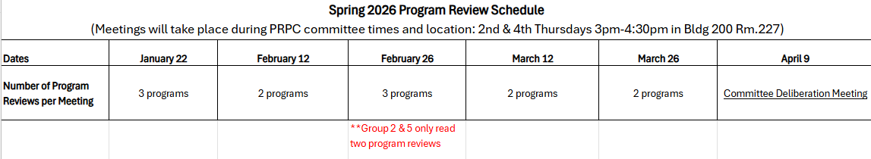
3:40pm-4:30pm | College-wide Data Presentation | - College-wide data will be presented to the committee

RESOURCES
Upcoming Meetings: 11/27 (no meeting due to Thanksgiving Break), 12/11

