Spring 2025 SLOA Committee Meeting Agenda
Friday-May 2nd, 2025-Noon- 1:00 PM (Room 904-in-person)

Meeting called by George Bonnand, Chair
Members: Caleb Petrie; Toni Nielson; George Bonnand; Deanna Smedley; Matthew Tribbe; Wendy Perez; Sean Sheil; Michael Mueller; Anna Shyrokova; Phat Truong; Karin Pavelek; Anastasia Nagel

Resources: José Ramón Núñez; Daniel Berumen; Committees@fullcoll.edu
Agenda Items

Assignment of Meeting Minutes Scribe
Approval of Agenda for today’s meeting (See below)-

Topics | Supporting Document Filename | Bring Copy
- Review and approval of proposed agenda for today (5-2-25). (see attachment) |  | No
- Review and approval of previous meeting minutes on 3-7-25 |  | No
- Assignment of Meeting Minutes Scribe (G. Bonnand) |  | No
- Elumen Dashboard |  | No
- Elumen assessments for Spring 2025 |  | No
- Insights update |  | No
- Review and comments on “SLOA Website” problem and issues |  | No
- Other-Issues, problems, reports. |  | Yes as necessary
- Open training session on Elumen-After meeting. |  | Yes as necessary

The zoom link recording for this meeting is below:

https://fullcoll-edu.zoom.us/rec/share/iKyk_VE-934N_umvY-lg-QfWVvfn_e--QvLmb2sJlmnhkClh4ThTD1w0WTJVROXO.F9osVDq1Vlyhk0-M?startTime=1746204607000

Please find below a very brief and short summary of the meeting minutes for the in-person SLOA meeting on 5-2-25. This meeting was held in room 904 in building 900 at approximately 12:05PM. (Meeting minutes taken and written by George Bonnand).

The meeting started at approximately 12:05 PM on 5-2-25 in room 904 with the following members present:

- George Bonnand
- Caleb Petrie
- Deanna Smedley
- Anna Shyrokova
- Michael Mueller
- Phat Truong
- Mathew Tribbe
- Wendy Perez

Not present for this meeting are as follows:

- Karin Pavelek
- Sean Sheild
- Toni Nielson
- Ana Nagel

The following items were reviewed.

- Review and approval of proposed agenda for today (5-2-25). (see attachment)
- All members present approved of the agenda for 5-2-25.

- Review and approval of previous meeting minutes on 3-7-25
- All members present approved the minutes from the 3-7-25 meeting.

- Assignment of Meeting Minutes Scribe (G. Bonnand)
- George Bonnand volunteered to take the Meeting Minutes since he is recording it on Zoom.

- Elumen Dashboard
- Committees members discuss the Elumen dashboard and the data on the dashboard. Many of the committee members have made big advancements in getting programs and courses mapped. Also, big advances in getting each course assessed have been made by divisions and departments. A discussion among all committee members regarding how to map courses outside of someone’s discipline occurred. The issue is that certain courses are in several programs across different disciplines. This does not allow committee members (or even faculty) to map course SLOs to Program SLO not in their area. In addition, courses that are mapped to one program will not show up as being not mapped to other programs. In summary it was agreed that committee members would consult discipline experts to determine which of their course CSLOs should be mapped to the PSLOs and then which PSLOs should be mapped to the ISLOs. This will require committee members to coordinate among each other to complete this mapping task.

- Elumen assessments for Spring 2025
- George Bonnand reminded committee members that assessments can be loaded for each course in all their departments. Assessments need to be created in order to assess the courses. A review of how to do this was done during the meeting using the “Strategic Planner” tab and the “Planner” tab.

- Insights update
- George Bonnand gave an overview of the insights program to all committee members and discussion ensued. A brief review of the insights functions and tabs behind the scenes was given to committee members including how to load/change SLOs was given. CSLO updates in Insights is a process and will be controlled. The proposed new “Coursedog” curriculum program and Insights do work together according to the information obtained during the demonstration of “Coursedog” approximately two weeks ago. A number of other curriculum programs have agreements (partnerships) with Insights for SLOs. The review of insights with committee members did highlight the need to automate the method to update the SLOs rather than use a CSV document to upload. Regardless of what program is selected to replace our current CNET program, the Insights program will be going live in Fall of 2025 barring any major issues. A question was asked regarding whether reports can be run in the Insights program. In order to run a program in Insights the “Demographic” information must be uploaded into Insights or conversely the information in Insights can be downloaded into Tableau which typically has that information. George Bonnand stated that ideally, we would like demographic performance reports by course; by department; by division; and by institution. The question of whether we will be loading information into Tableau will be discussed with Mr. Daniel Berumen this next week on Monday. Questions by committee members were asked as to how Canvas and Insights interact with each other in regard to assessments for each course. An explanation was given and shown on the screen as to how the “Rubrics” tool can be used in Canvas to attach CSLOs to individual assignments.

- Review and comments on “SLOA Website” problem and issues
- No comments were made by committee members. The website is up to date at this time however it may need some updates at a later date due to Insights implementation.

- Other-Issues, problems, reports.
- No major issues or problems were noted during the meeting. Three members stated their terms was up next semester. Matthew Tribbe will be leaving us and Brian Lopez will be joining the SLOAC for Fall 2025. Wendy Perez stated that Trisha Gonzales would be taking over for Wendy Perez pending Senate approval. Deanna Smedley stated her term was up next semester however no one has stepped forward in her department at this time. A reminder to all committee members was given to make sure that all replacement committee member must be senate approved.

- Open training session on Elumen-After meeting.
- Several members stayed after to ask questions regarding Elumen.

Meeting was adjourned at 12:55PM.

Note:

As mentioned during the meeting we have done a great job with making sure our courses have assessments and that our courses are mapped for the most part. Below (page 5) please see a screen shot of the 2024–2025-year end dashboard showing “Unmapped CSLOs” and “CSLOs not included in any Assessment Rubric”. In addition, please see screen shots of “Unmapped from PSLOs” and “Unmapped PSLOs” for each division (pages 6-15). When you are in Elumen, in the role of Division Coordinator click on the “SLO & Assessment” tab; then “SLO Listing” tab; then the “PSLOs” tab so you can see this information. If you click on the numbers in the boxes you should be able to see the “Unmapped” items for each.

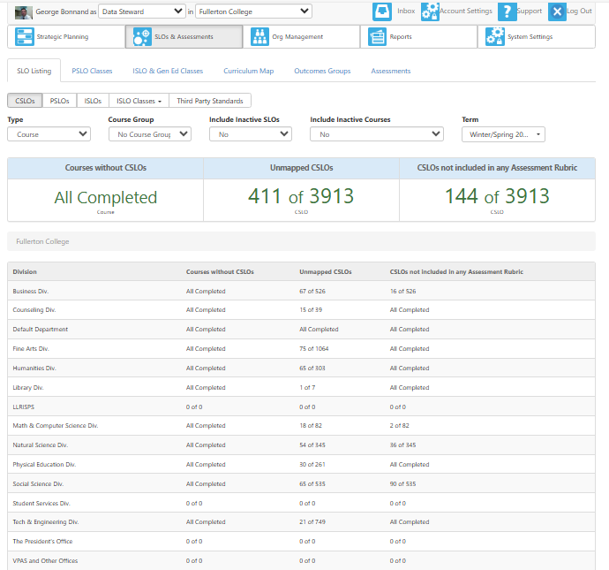

Business
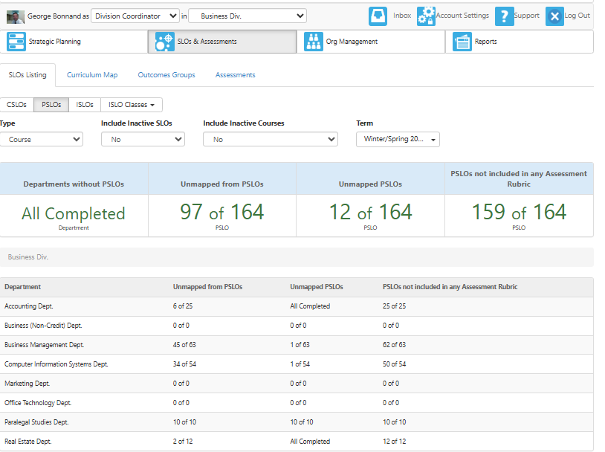

Counseling

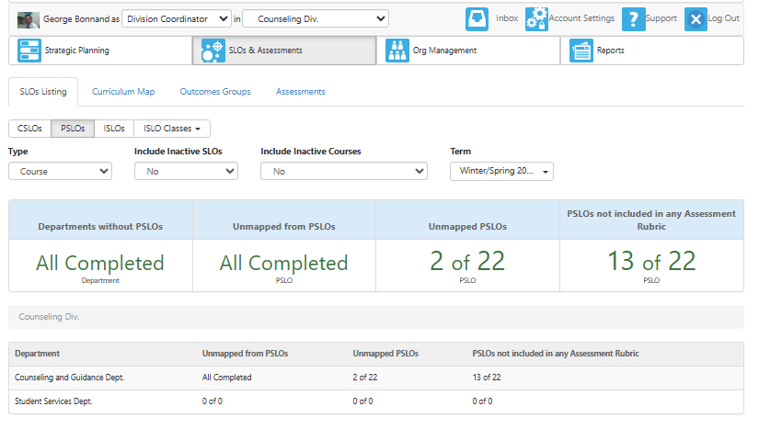

Fine Arts

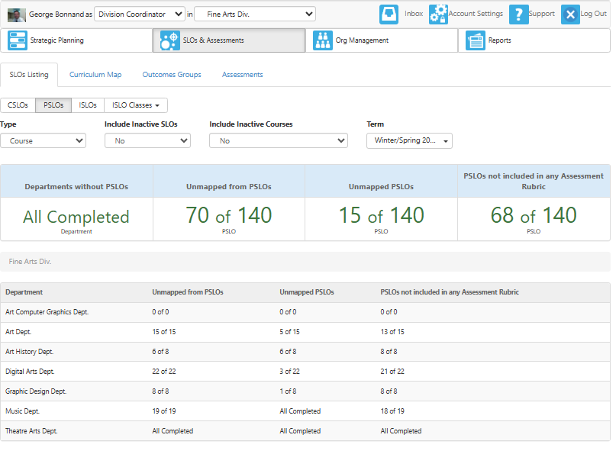

Humanities

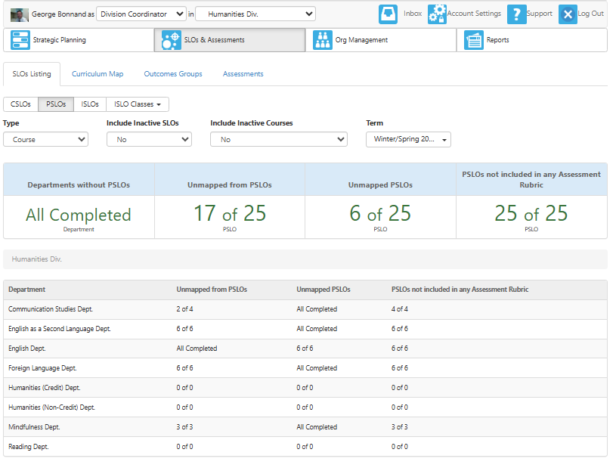

Library
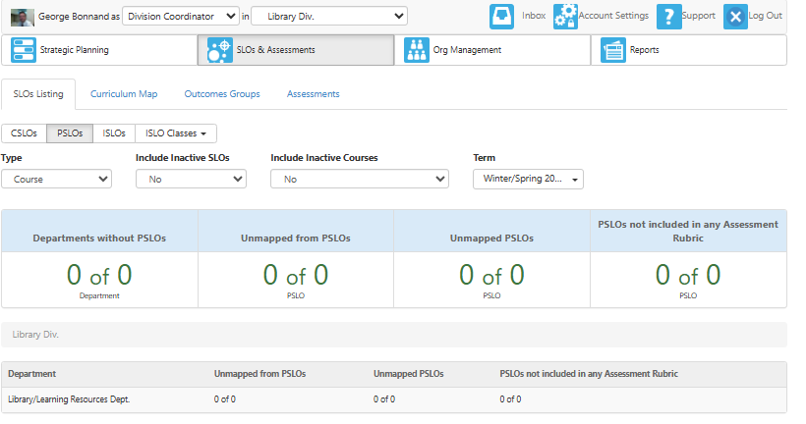

Math and Computer Science

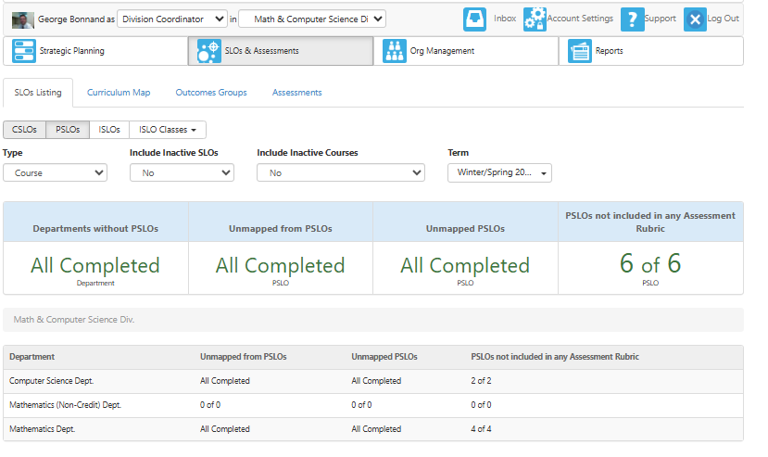

Natural Sciences

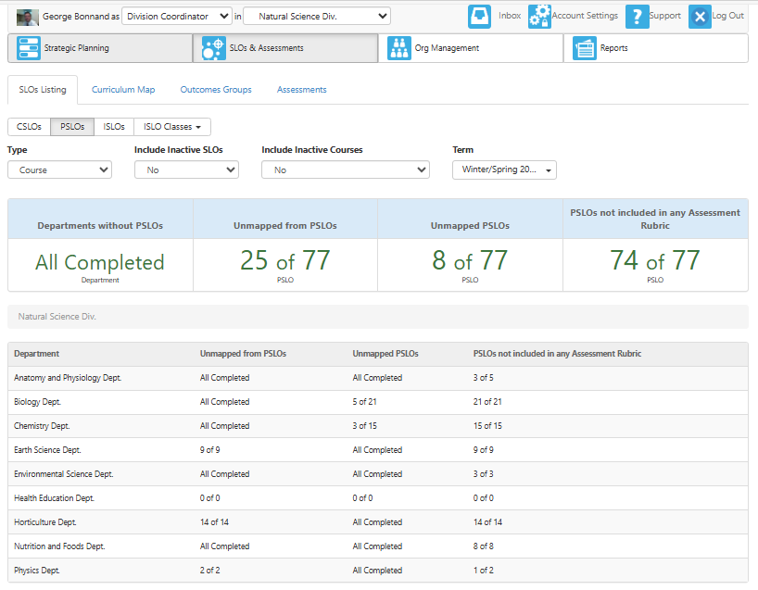

Physical Education

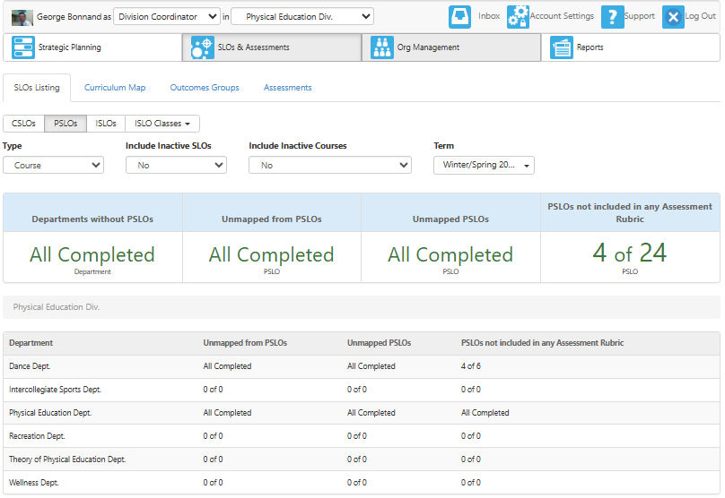

Social Sciences

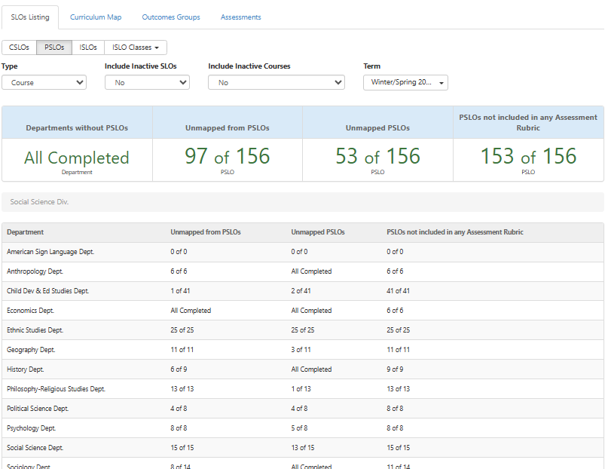

Technology and Engineering

