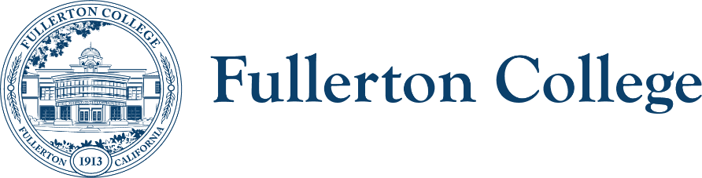
SEAC

Meeting Co-Chairs: Ziza Delgado & Anita Juarez
zdelgado@fullcoll.edu & ajuarez@fullcoll.edu
Date: Monday, October 6, 2025
Building 200, Room: 227

STUDENT EQUITY AND ACHIEVEMENT COMMITTEE (SEAC)

In order to facilitate our work together, we agree to the following commitments:
- Commit to open, honest and constructive dialogue.  - Listen to the perspectives of others and seek understanding.  - Create and maintain a culture of trust, honesty, support and confidentiality.  - Respect each other's lived experiences, perspectives and ideas.  - Prioritize projects that are in the best interest of the Fullerton College community through the lens of Access, Community and Learning. | - Collaborate on shared goals with a growth mindset for continuous improvement.  - Be present, engaged and prepared.  - Following the meeting, speak positively and support the work of the team.  - Have fun.

October 6th 2025
FOLLOW UP ITEMS – 10 min.
- Housekeeping: Call to Order, Public Comments, Announcements, and Approval of Notes > Meeting Notes 9.15.25
- Committee Liaisons Related Reports
  - Staff Development
  - Diversity Committee
  - Guided Pathways

MAIN AGENDA
TIME | TOPIC | PRESENTER | PURPOSE | ACTION
5 min | Update on SEPI Collective December 4-5th in San Diego. Event Info | Ziza | Information
30 mins | Continued Discussion: Review committee mission/purpose and membership per Integrated Planning Manual | Anita, Ziza | Review & Decision
55 mins | Endorsement of 2nd Draft of 2025-2028 SEA Plan for Shared Governance Distribution & Next Steps | Anita, Ziza, Ericka | Decision & Update
 | Adjourn meeting | Ziza

RESOURCES
- Website Hyperlinks: SEAC & FACULTY SENATE
- SEAC Teams Hyperlink (Agenda & Notes)

