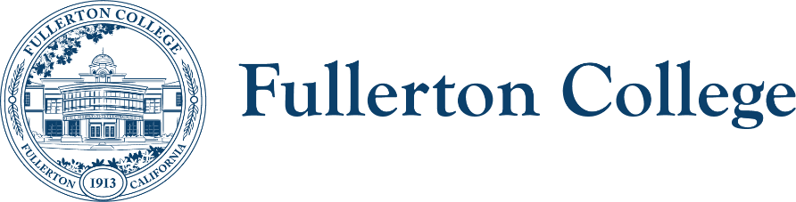
Diversity Advisory Committee
ZOOM: link
Meeting Lead: Connie Moreno Yamashiro
Sept. 4, 2024

Diversity Advisory Committee Meeting Agenda
Purpose:
The mission of the Campus Advisory Committee is to work with the campus community to develop, recommend, and assess appropriate policies, programs and strategies to achieve a diverse, inclusive and just campus.
The committee is responsible for making recommendations to the President’s Advisory Council on diversity issues that affect the experiences of all members of the Fullerton College community.

In order to facilitate our work together, we agree to the following commitments:
- Commit to open, honest and constructive dialogue.  - Listen to the perspectives of others and seek understanding.  - Create and maintain a culture of trust, honesty, support and confidentiality.  - Respect each other's lived experiences, perspectives and ideas.  - Prioritize projects that are in the best interest of the Fullerton College community through the lens of Access, Community and Learning. | - Collaborate on shared goals with a growth mindset for continuous improvement.  - Be present, engaged and prepared.  - Following the meeting, speak positively and support the work of the team.  - Have fun.

Outcomes:
- Decide on the 24/25 academic year goals

WELCOME ACTIVITY
Discuss how we want to conduct this portion of the meeting

FOLLOW UP ITEMS – 10 min.
- Review and Approve the May 2024 meeting minutes

MAIN AGENDA
TIME | TOPIC | PRESENTER | PURPOSE | ACTION
 | Welcome: Katarina Barela-Perez
 | End of Year Summary
Follow up from Meeting with President Olivo:
Discuss Culturally Relevant Art Protocol
Sense of Belonging project
 | Discuss New Goals
24-25 Meetings - 1st meeting Wednesday of the month from 3-4:30pm via Zoom
  - September 4, 2024
  - October 2, 2024
  - November 6, 2024
  - December 4, 2024
  - February 5, 2025
  - March 5, 2025
  - April 2, 2025
  - May 7, 2025

RESOURCES
End of Year Summary

Next meeting: Wednesday, October 2nd, 2024 from 3:00PM – 4:30PM

