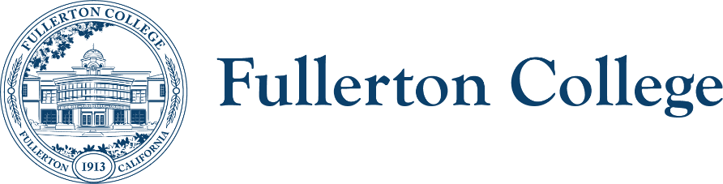
Diversity Advisory Committee
ZOOM: link
Meeting Lead: Connie Moreno Yamashiro
Nov. 6, 2024

Diversity Advisory Committee Meeting Agenda
Purpose:
The mission of the Campus Advisory Committee is to work with the campus community to develop, recommend, and assess appropriate policies, programs and strategies to achieve a diverse, inclusive and just campus.
The committee is responsible for making recommendations to the President’s Advisory Council on diversity issues that affect the experiences of all members of the Fullerton College community.

In order to facilitate our work together, we agree to the following commitments:
- Commit to open, honest and constructive dialogue.  - Listen to the perspectives of others and seek understanding.  - Create and maintain a culture of trust, honesty, support and confidentiality.  - Respect each other's lived experiences, perspectives and ideas.  - Prioritize projects that are in the best interest of the Fullerton College community through the lens of Access, Community and Learning. | - Collaborate on shared goals with a growth mindset for continuous improvement.  - Be present, engaged and prepared.  - Following the meeting, speak positively and support the work of the team.  - Have fun.

Outcomes:
- Decide on the 24/25 academic year goals
WELCOME ACTIVITY

FOLLOW UP ITEMS – 10 min.
- N/A

MAIN AGENDA
TIME | TOPIC | PRESENTER | PURPOSE | ACTION
 | Review October meeting notes
 | New meeting time proposal
 | Review survey results for 24/25 goals
 | If selected: List of ADA concerns
 | Formal Process for CRA

RESOURCES
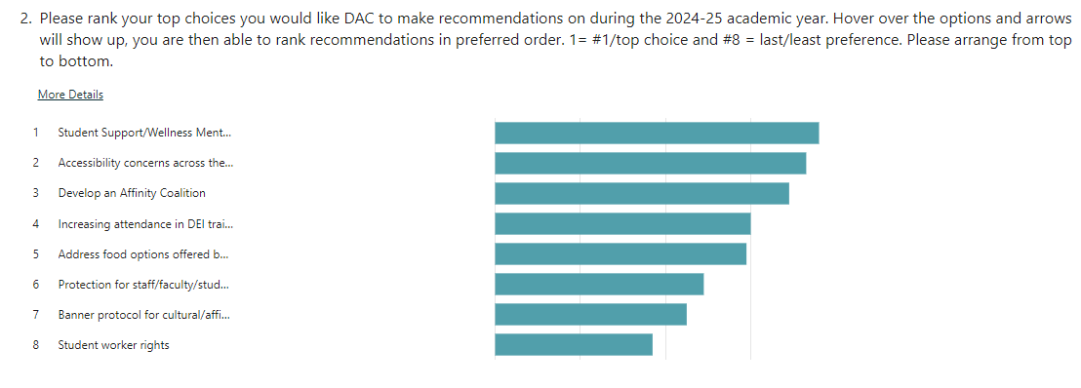
Next meeting: Wednesday, December 4th, 2024 from 3:00PM – 4:30PM

