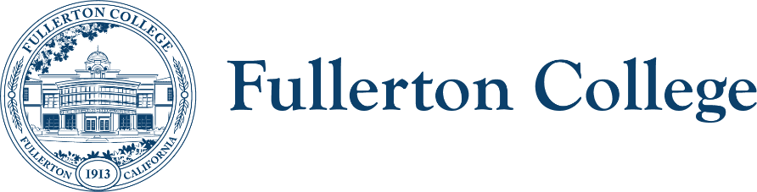
Campus Collaborations Committee Notes

Co-Chairs: Daniel Berumen, Bridget Kominek
Members: Jennifer Merchant, Jeanne Costello, Bridget Kominek, Mary Bogan, Ericka Adakai, Anita Juarez, Darnell Kemp, Michael Mangan, Evelyn Lindley, Connie Moreno-Yamashiro, Tyler Deacy, Roman De Jesus, John Ison, Tam Contreras, Valerie Salazar, (ACT Director- Vacant), Cecilia Arriaza, Albert Abutin, Kim Vandervort, Annika Shellenbarger, Rolando Sanabria, Miranda Bates
Recorder: Bianca Gladen

Absent: Mary Bogan, Darnell Kemp, Michael Mangan, Tyler Deacy, Valerie Salazar, Kim Vandervort, Rolondo Sanabria, Miranda Bates

Location: Zoom

HOUSEKEEPING
- Approval of Previous Notes
  - The previous notes were approved by the committee.
TOPICS FOR DISCUSSION
- Review Campus Collaborations Committee mission and membership per Integrated Planning Manual
  - During the review of committee membership, we noticed that some shared governance committee co-chairs were not included and had not been added to the calendar invitations.
  - Action Item: Update the membership list to include the missing co-chairs and ensure they are added to calendar invites.
- Update on the Strategic Plan and college mission, vision, and values from 5/27 Board of Trustees meeting
  - The Board did not approve the College Mission and Values and declined to place the item on the agenda for a vote. Dr. Olivo will convene a small PAC workgroup to discuss next steps for moving forward.
- Update on Ruffalo Noel Levitz (RNL) district-wide strategic enrollment action plans
  - The Chancellor’s staff agreed to hire a consulting firm to review the strategic enrollment plan. The district will provide a report focusing on outreach and onboarding, student success, online education, and course scheduling, with a final report expected in June. CRM software will be used to track prospective students and interventions. Several action plans will be shared in the near future.
- Update on Student Equity and Achievement Plan (SEA Plan) draft and timeline
  - The SEA Plan will be coming to the participatory bodies for a vote soon. Anita Juarez presented an update on the SEA plan via PowerPoint. The final draft will be submitted 11/30/2025. The plan prioritizes disproportionately impacted groups, specifically Black and Latinx students, and is guided by a framework which emphasizes supporting students holistically rather than focusing solely on access. Key metrics include enrollment, transfer-level math and English completion, persistence, program completion, and transfer. Strategies to achieve these goals include improving data usage, implementing equity-focused outreach, pursuing instructional reforms, expanding Starfish, providing holistic support services, increasing diverse faculty and tutors, and institutionalizing the student advocate program. The draft was informed by campuswide feedback and questionnaires.
- Update on Strategic Enrollment and Retention Plan draft and Timeline
  - The committee is working to align its efforts with both campus and district strategic plans, with a major initiative focused on implementing the Element451 CRM to streamline communication with prospective students. The CRM will track the full enrollment funnel—from prospective students to applicants to registration—while reducing duplicate communications and supporting equity-focused outreach, including multilingual campaigns. The workgroup meets biweekly, and the CRM is expected to be fully operational within a month. Drafting of the strategic enrollment plan will begin this semester, with a target to have a draft ready by December. District IS is coordinating to ensure Element451 integrates with Banner.
- Member announcements
  - Aspen Transfer Intensive: Collaboration with CSU Fullerton to improve transfer pipeline; developing Strategic Transfer Excellence Plan (STEP). More updates will be provided throughout the semester.
  - Cultural Relevant Art Protocol: Proposals now reviewed by Diversity Advisory Committee once per semester.
  - Professional Learning Committee & Library: Five-author speaker series confirmed (Oct–Apr), featuring writers from Native Hawaiian, undocumented, Black, Palestinian, and Southeast Asian backgrounds. More information to come from Staff Development.
  - HSI Transformation Team: First meeting Sept. 15; HSI Celebration Sept. 12 with student engagement activities. Manuscript on HSI work submitted for publication.
  - New Staff: Introduction of Dr. Vinny Wu, Senior Research Analyst.
- Discussion of future agenda items and adjournment
  - Student Equity Plan (final draft review)
  - Strategic Enrollment & Retention Plan
  - District RNL Strategic Enrollment Plan
  - Common course numbering and new local GE requirements (later in semester)

Meeting adjourned at 1:55pm

UPCOMING Fall 2025 MEETINGS: 10/7, 11/4, and 12/2

