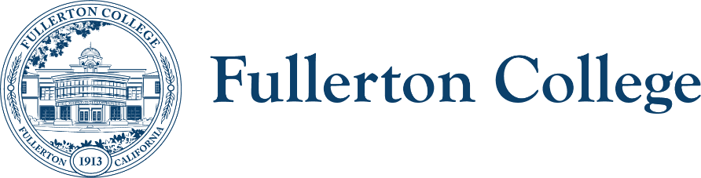
Campus Collaborations Committee Notes

Co-Chairs: Daniel Berumen, Bridget Kominek
Members: Albert Abutin, Anita Juarez, Annika Shellenbarger, Arnette Edwards, Cecilia Arriaza, Connie Moreno-Yamashiro, Cynthia Guardado, Curtis Galvez, Darnell Kemp, Ericka Adakai, Evelyn Lindley, Garrett Campbell, George Bonnand, Henry Hua, Jennifer Merchant, Jeanne Costello, Jodi Balma, John Ison, Johnathon Krok, Jorge Arrendondo, Kim Vandervort, Marietta Gilliard, Mary Bogan, Michael Mangan, Miranda Bates, Roman De Jesus, Rolando Sanabria, Tam Contreras, Theresa Ullrich, Toni Nielson, Valerie Salazar, Ziza Delgado

Recorder: Bianca Gladen

Absent: Mary Bogan, Mike Mangan, Connie Moreno Yamashiro, Jorge Arrendondo, Curtis Galvez, Garrett Campbell, Kim Vandervort, Rolando Sanabria, Miranda Bates, Marietta Gilliard, Arnette Edwards, Johnathon Krok, Henry Hua, Jodi Balma, Toni Nielson

Location: Zoom
HOUSEKEEPING
- Call to Order
- Review of Previous Notes
  - Approved
- Co-chair report
  - None
TOPICS FOR DISCUSSION
- 2025-2028 Study Equity and Achievement Plan (Information, Ericka Adakai and Anita Juarez)
  - The SEA Plan draft has been or will be voted on at Classified Senate, Faculty Senate, and the President's Advisory Council (PAC). Once it is approved at all three bodies, it will be submitted to the state
  - Chair of SEAC, shared that the second draft of the 2025–2028 SEA Plan has been distributed. The plan requires reporting on five key metrics and outlining campus efforts over the past three years as well as planned actions for the next three. The primary focus will be on Black and Latinx student populations as the designated disproportionately impacted (DI) groups. The committee divided into writing teams to gather and compile relevant information for the first draft of the plan.
  - Feedback on the first draft suggested narrowing the number of strategies included under each metric. The final draft is due in early December. Upcoming additions to the final version will include a summary of expenditures from 2022–2025, a review of the previous plan, and an executive summary. A key change from the first to the second draft is the increased emphasis on basic needs, recognizing them as a foundational component of equity work.
- Shared Governance Committee Procedures (Discussion, Bianca Gladen and Bridget Kominek)
  - Review committee description template
  - Feedback on proposed guidelines for chairs & co-chairs (rough draft)
    - New committee chairs have expressed uncertainty about their roles, responsibilities, and the rules or procedures they need to follow.
    - Include guidance on effective strategies for recruiting committee representatives in this document.
    - There is often confusion about which committees follow formal procedures (Brown Act) and which operate more informally. Clear procedures for both would be helpful.
    - A member noted that committee meetings should go beyond just updates and announcements; they should emphasize collaboration and action items.
    - Manager selection processes appear inconsistent. Including term limits or start/end dates could provide transparency and help members understand how long a manager has served (or will serve) on a committee.
    - Clarifying the number, role, and purpose of resource members could help committees identify the right people for those roles, as opposed to having attendees who function more as guests.
  - Feedback on new Membership Roster Template
    - Members provided feedback on the new Membership Roster Template. It was suggested to include a note on the form stating: "If you have any changes to your roster after submitting this form, please email committees@fullcoll.edu."
    - A question was raised regarding whether committees are required to use a specific agenda template.
  - Update on committee websites and uniform landing pages
    - TABLED
- Student Learning Outcome Assessments Committee (Information, George Bonnand)
  - Updates on current implementation of the new Insights program, which integrates with Canvas and utilizes rubrics for assessment. Additionally, the Elumen system is officially entering its end-of-life phase this semester, and faculty will no longer be using it moving forward.
  - Elumen, the current SLO (Student Learning Outcomes) application, is being phased out by December 2025. Since Elumen was acquired by Instructure, its functionality has been incorporated into a new platform called Insights, which integrates with Canvas. The migration of data from Elumen to Insights was completed last semester, and implementation is underway this semester.
  - Faculty are now using Insights & Rubrics to manage SLOs.
  - A few PowerPoints were shared with the committee:
    - Insights Presentation-8-20-25-updated.pptx
    - INSIGHTS TRAINING 10.09.25.pptx
  - George Bonnand will provide a detailed walkthrough on accessing SLOs using Insights at the next Faculty Senate meeting.
- Additional member updates and announcements
  - The Fullerton College Transfer Center will host the annual Fall Transfer Fair on October 21, 2025, from 10:00 a.m. to 1:00 p.m. in the campus quad.
  - The annual Fall Mixer, Harvest Haunt, co-hosted with Associated Students, will take place on October 29, 2025, from 11:00 a.m. to 2:00 p.m.
  - The FC Professional Development office will be holding their first of five Speaker Series event. This event will be hosted by APIDA on 10/08/2025 in the 2400 building, Room 107/courtyard. Speaker, Brandy Nālani McDougall is an Associate Professor of American Studies (specializing in Indigenous studies) and the author of two poetry collections.
  - Reminder for committee co-chairs to submit committee agendas and notes to committees@fullcoll.edu
- Discussion of future agenda items and adjournment
  - Meeting adjourned 1:53pm

UPCOMING Fall 2025 MEETINGS: 11/4, 12/2

