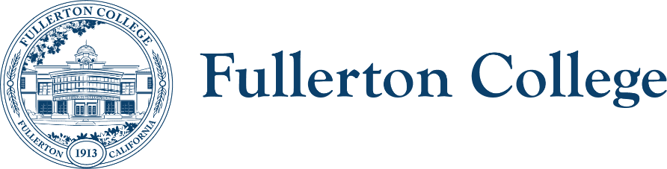
Campus Collaborations Committee Meeting Agenda

Co-Chairs: Daniel Berumen, Bridget Kominek
Members: Jennifer Merchant, Jeanne Costello, Bridget Kominek, Mary Bogan, Ericka Adakai, Anita Juarez, Ziza Delgado, Darnell Kemp, Michael Mangan, Evelyn Lindley, Connie Moreno-Yamashiro, Jorge Arrendondo, Roman De Jesus, John Ison, Tam Contreras, Valerie Salazar, Curtis Galvez, Cecilia Arriaza, Albert Abutin, Garrett Campbell, Kim Vandervort, Annika Shellenbarger, Rolando Sanabria, Miranda Bates, Marietta Gilliard, Arnette Edwards, Johnathon Krok, Theresa Ullrich, Henry Hua, Jodi Balma, George Bonnand, Cynthia Guardado, Curtis Galvez, Toni Nielson
Recorder: Bianca Gladen

Location: Zoom
HOUSEKEEPING
- Call to Order
- Review of Previous Notes
- Co-chair report
TOPICS FOR DISCUSSION
- 2025-2028 Study Equity and Achievement Plan (Information, Ericka Adakai and Anita Juarez)
  - The SEA Plan draft has been or will be voted on at Classified Senate, Faculty Senate, and the President's Advisory Council (PAC). Once it is approved at all three bodies, it will be submitted to the state
- Shared Governance Committee Procedures (Discussion, Bianca Gladen and Bridget Kominek)
  - Review committee description template
  - Feedback on proposed guidelines for chairs & co-chairs
  - Feedback on new Membership Roster Template
  - Update on committee websites and uniform landing pages
- Student Learning Outcome Assessments Committee (Information, George Bonnand)
  - Updates on current implementation of the new Insights program, which integrates with Canvas and utilizes rubrics for assessment. Additionally, the Elumen system is officially entering its end-of-life phase this semester, and faculty will no longer be using it moving forward.
- Additional member updates and announcements
- Discussion of future agenda items and adjournment

UPCOMING Fall 2025 MEETINGS: 11/4 and 12/2

