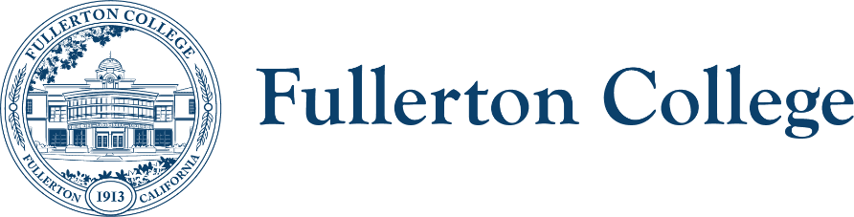
Sustainability Committee
ZOOM: Link.
Meeting Leads: Tyler Deacy, Roman de Jesus
tdeacy@fullcoll.edu
5/6/2025

Sustainability Committee
Purpose:
The purpose of this meeting is to prepare for the Earth Week events and other Spring activities.

Members:
Co-Chairs:  - Tyler Deacy (FC Interim Director of Sustainability)  - Roman de Jesus (Natural Sciences, Earth Science)  Managers:  - John Quinn (Manager, Facilities)  - Khaoi Mady (Manager, ACT)  Students:  - Jules Drummer (Student Representative)  - Holden Zambon (Student Representative)  - Dani Soto (Student Representative) | Faculty:  - Josh Ashenmiller (Social Sciences, History)  - Sean Chamberlin (Natural Sciences, Earth Sciences)  - Daniel Scarpa (Humanities, English)  - Aline Gregorio (Social Sciences, Geography)  Classified:  - Nichole Crockrom (Administrative Assistant, Campus Safety)

Outcomes:
- Recap Spring Events
- Provide updates for STARS Report

AGENDA
TIME | TOPIC | PRESENTER | PURPOSE | ACTION
5 min | Manager Reports | Managers | Updates
5 min | Student Reports | Students | Updates
5 min | Faculty Reports | Faculty | Updates
5 min | Classified Reports | Classified | Updates
10 min | Director Report  - Solar Update | Tyler Deacy | Updates
10 min | Earth Day Recap | Tyler Deacy | Plan for Earth Week
5 min | STARS 2025 Updates | Tyler Deacy | 2024-25 Planning
20 min | PAC / Board Year-End Presentations | Tyler Deacy | Input from Committee
10 min | Fall Plans |  | Discuss upcoming changes in District/Campus sustainability

RESOURCES
- Campus Sustainability Plan

Spring 2025 Meetings: Feb. 4th | Mar. 4th | May. 6th

