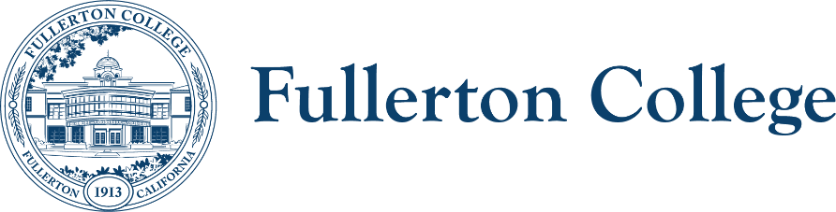
Campus Collaborations Committee Meeting Agenda

Co-Chairs: Daniel Berumen, Bridget Kominek
Members: Jennifer Merchant, Jeanne Costello, Bridget Kominek, Mary Bogan, Ericka Adakai, Anita Juarez, Darnell Kemp, Michael Mangan, Evelyn Lindley, Connie Moreno-Yamashiro, Tyler Deacy, Roman De Jesus, John Ison, Tam Contreras, Valerie Salazar, (ACT Director- Vacant), Cecilia Arriaza, Albert Abutin, Kim Vandervort, Annika Shellenbarger, Rolando Sanabria, Miranda Bates
Recorder: Bianca Gladen

Location: Zoom

HOUSEKEEPING
- Call to Order
- Approval of Previous Notes
- Co-chair report
TOPICS FOR DISCUSSION
- Review Campus Collaborations Committee mission and membership per Integrated Planning Manual
- Update on the Strategic Plan and college mission, vision, and values from 5/27 Board of Trustees meeting
- Update on Ruffalo Noel Levitz (RNL) district-wide strategic enrollment action plans
- Update on Student Equity and Achievement Plan (SEA Plan) draft and timeline
- Update on Strategic Enrollment and Retention Plan draft and timeline
- Member announcements
- Discussion of future agenda items and adjournment

UPCOMING Fall 2025 MEETINGS: 10/7, 11/4, and 12/2

