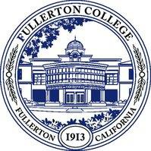
Gilbert J. Contreras, Ph.D. Vice President of Student Services

Safety Committee Meeting
July 11, 2023
Cruz Reynoso Hall, Room 227

- Welcome/Introductions
- Fullerton College Safety Committee vs NOCCCD Workplace Safety Committee
- Deliverables for 2023/2024
- Committee Meeting Schedule
- Around the Room

