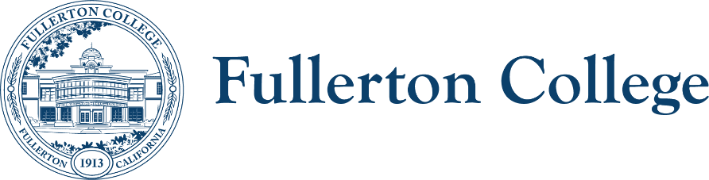

Accreditation Steering Commitee Notes

Co-Chairs: Danielle Fouquette, Daniel Berumen Members: Bridget Kominek, Carlos Ayon, Carolina Santillan, Dani Wilson, Henry Hua, Kim Vandervort, Martha Smith, Michael Mangan, Jeanette Rodriguez
Student Representative: N/A
Resource Member: Jose Ramon Nunez
Recorder: N/A

Location: Room 112 (Humanities Building)

HOUSEKEEPING
- Call to Order: 3:05pm
- Agenda
- Approval of Notes from February 4, 2025
  - February 4, 2025 meeting notes approved
- Reschedule April meeting to Tuesday March 25 (proposed)
  - Discussion of rescheduled April ASC meeting—proposed date of March 25 does not work for enough members, so the meeting Friday, March 21 writing team meeting will include all members of the ASC.
- Public Comment
- Announcements

OLD BUSINESS (Discussion with Possible Action)
- Review Draft Strategic Plan: Mission, Vision, Core Values, Goals, and Objectives
  - Draft 2025-2029 Strategic Plan crosswalk activity with ACCJC Standard and Review Criteria using crosswalk chart.
  - As we give feedback on the draft strategic plan, members of the ASC can give feedback in light of the relevant standards
  - We want to be thinking about what the strategic plan implies about the practices on our campus that we want to account for an document in the next ISER
  - Daniel shared a presentation giving an update on the strategic planning process the campus has engaged with over the last month and the current draft of the mission including defining key terms in the revised draft mission as well as our plan’s relationship between Vision 2030, the SEA Plan, and other campus plans
  - The committee reviewed the goals and objectives in detail, considering feedback on the draft.
    - Goal 1, Objective 5: Dani will share with the Professional Learning Committee for suggestions on wording to make it more focused and specific
    - Goal 2, Objective 5: Discussion of how to make it more specific and highlight connections with the communities
    - Goal 3: Focus is more operational, business practices, and other accreditation-related more operational processes. There’s interest in changing the language to make it less jargon-heavy
    - Goal 3, Objective 2: Discussion of how to reword it to update and broaden it to focus less on specific flexible course schedules
    - Goal 3 is more of an internal goal articulating the ways we want to see our campus improve our processes and structure to support instruction and student services that student need
    - Discussion of sustainability goals and how to articulate them with our current phase in growth and within our scope of responsibility
    - Discussion of 1.2 review criteria #3: what is our “scope of responsibility” in general?
    - Might we revise our goals to align with the three goals in Vision 2030? Access, Support, Success seems like a logical progression of the ideas if we adopt the three areas of goals articulated in Vision 2030. The existing objectives would be moved into the relevant goal, and the goal would be fleshed out. Draft of what this might look like is on the draft strategic plan at the bottom
    - Discussion of the importance of equity being infused through the three goals rather than having one “equity” goal
    - Discussion of the extent to which we want to prioritize dual enrollment and career education. What’s the value of specifically call out Dual Enrollment versus a more general language that would cover
    - Highlighting dual enrollment and career education students to highlight for equitable access and outcomes—align with second review criteria under standard 2.8, as possible useful language for talking about how we increase access to students who are historically under-resourced
    - Idea for additions: providing students who are not primarily English speaking access to services. Possibility for objective under the “Support” goal that highlights efforts to provide multilingual support for students
    - Possible fourth goal: equity in community? Equitable connections? Ensuring equity in access, promoting equity in the community, service? Or are relevant objectives that would be associated with equity in community something that could fit with the three existing goals?
      - Possible goals: partnering with community organizations
    - Suggestion: add critical consciousness as a goal, highlight grassroots efforts and ensuring the campus community reflects and is part of the larger community we serve

NEW BUSINESS (Discussion with Possible Action)
- Review Planning Manual Section II

OTHER TOPICS FOR DISCUSSION
- Other Topics
- Adjournment

NEXT MEETING: March 21, 2025

