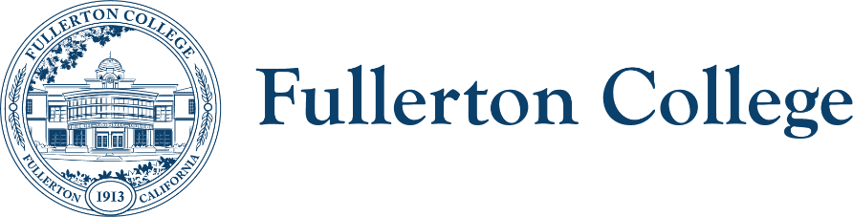 **SEAC**

Meeting Co-Chairs: Ericka Adakai & Anita Juarez

[eadakai@fullcoll.edu](mailto:eadakai@fullcoll.edu) & [ajuarez@fullcoll.edu](mailto:ajuarez@fullcoll.edu)

Date: Monday, March 17, 2025

**STUDENT EQUITY AND ACHIEVEMENT (SEA) COMMITTEE**

**Purpose:**

The Student Equity and Achievement Committee (SEAC) was created in Fall 2019 by mutual agreement of the President and the Faculty Senate to provide leadership advocacy, and the institutional guidance and vision for coordinating campus-wide student success efforts affecting basic skills, transfer, Career Technical Education, completion, diversity, and equity at Fullerton College. This committee will be responsible for the development of the SEA plan required by the State. Additionally, the committee provides recommendations on how to disseminate State Student Equity and Achievement (SEA) funds most effectively to improve and promote achievement and equity.

With the support and collaboration of the entire campus community, the committee will gather and share information and data, consult with constituencies, and serve as a repository of knowledge and as a catalyst for student success and achievement activities on campus. Engaging in this process, SEAC will prioritize and offer solutions, recommend resources, and evaluate effectiveness using appropriate indicators of student success.

**In order to facilitate our work together, we agree to the following commitments:**

|  |  |
| --- | --- |
| * Commit to open, honest and constructive dialogue. * Listen to the perspectives of others and seek understanding. * Create and maintain a culture of trust, honesty, support and confidentiality. * Respect each other's lived experiences, perspectives and ideas. * Prioritize projects that are in the best interest of the Fullerton College community through the lens of Access, Community and Learning. | * Collaborate on shared goals with a growth mindset for continuous improvement. * Be present, engaged and prepared. * Following the meeting, speak positively and support the work of the team. * Have fun. |

|  |
| --- |
| **FOLLOW UP ITEMS – 15 min.** |
| * Housekeeping: Call to Order, Public Comments, Announcements, and Approval of Notes * Committee Liaisons Related Reports:   + Staff Development   + Diversity Committee   + Guided Pathways |

|  |  |  |  |
| --- | --- | --- | --- |
| **MAIN AGENDA** | | | |
| **TIME** | **TOPIC** | **PRESENTER** | **PURPOSE & ACTION** |
| 3:15-3:40pm | Strategic Plan | Daniel | Share FC strategic plan to ensure it aligns with 2025-2028 SEA plan |
| 3:40-4:05pm | Data Overview | Daniel | Brief overview/introduction of FC data methodology, results, and dashboards |
| 4:10-4:25pm | Finalize writing teams   * Reminders:   + Feedback on who we want to hear back from   + [Structured Reflections Tool](https://fullcolledu.sharepoint.com/:w:/r/sites/SEAC/Shared%20Documents/General/2024-2025/CCHALES%20Student%20Equity%20Planning%20Workshop_01.27.25-01.28.25/2025-28%20SEP%20-%20Structured%20Reflections%20for%20Racial%20Equity_WORKSHEET%20TO%20COMPLETE.docx?d=wd588d193fa464aa487d1b67fe9f7466d&csf=1&web=1&e=r5nU3Q) | Ericka & Anita |  |
| 4:25-4:30pm | Homework |  |  |

|  |
| --- |
| **RESOURCES** |
| * Website Hyperlinks: [SEAC](https://committees.fullcoll.edu/student-equity-and-achievement/) & [FACULTY SENATE](https://facultysenate.fullcoll.edu/) * [SEAC Teams](https://teams.microsoft.com/l/team/19%3A9d94d9fa74394139ab5d00635dfd809c%40thread.tacv2/conversations?groupId=1f612edf-b766-46ae-839f-9beb6d3d667d&tenantId=f8b4752f-8a29-4d0e-97b5-f7428505ab38) Hyperlink (Agenda & Notes) |