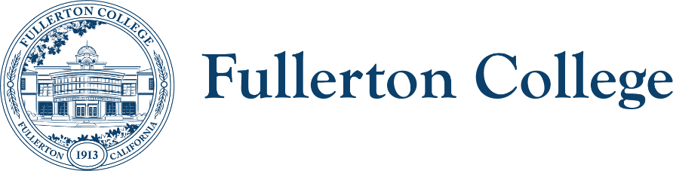 **Sustainability Committee**

ZOOM: [Link.](https://www.google.com/url?q=https://fullcoll-edu.zoom.us/j/82615239267?pwd%3DOEFYemtDTlVTZjJBdkg4VnA2UFNQdz09&sa=D&source=editors&ust=1724795715987972&usg=AOvVaw2STRIXvaBGCUs_BPmxjaJR)

Meeting Leads: Tyler Deacy, Roman de Jesus

tdeacy@fullcoll.edu

3/4/2025

**Sustainability Committee**

**Purpose:**

The purpose of this meeting is to prepare for the Earth Week events and other Spring activities.

**Members:**

|  |  |
| --- | --- |
| Co-Chairs:   * Tyler Deacy (FC Interim Director of Sustainability) * Roman de Jesus (Natural Sciences, Earth Science)   Managers:   * John Quinn (Manager, Facilities) * Khaoi Mady (Manager, ACT)   Students:   * Jules Drummer (Student Representative) * Holden Zambon (Student Representative) * Dani Soto (Student Representative) | Faculty:   * Josh Ashenmiller (Social Sciences, History) * Sean Chamberlin (Natural Sciences, Earth Sciences) * Daniel Scarpa (Humanities, English) * Aline Gregorio (Social Sciences, Geography)   Classified:   * Nichole Crockrom (Administrative Assistant, Campus Safety) |

**Outcomes:**

* Prepare logistics for Earth Week
* Keep up work on EJ Fellowship Grant
* Provide updates for STARS Report

|  |  |  |  |  |
| --- | --- | --- | --- | --- |
| **AGENDA** | | | | |
| **TIME** | **TOPIC** | **PRESENTER** | **PURPOSE** | **ACTION** | |
| 5 min | Manager Reports | Managers | Updates |  | |
| 5 min | Student Reports   * Dani has been working with the LGBTQ Center as part of the EJ Fellowship – been a great learning experience so far as she makes social media posts for them and works on grants. * Touch base meeting scheduled for 3/14 – Olivia and Jessica are visiting the site. Professional workshop was last week but not many people showed up (5-6). * Holden reports that other students have asked him about our recycling program. Should go back to A.S. sometime in the near future now that clubs have started again. Holden will bring to next A.S. meeting he can attend. | Students | Updates |  | |
| 5 min | Faculty Reports   * Environmental Science instructor candidates will be interviewed in the next few weeks! * CA CCCO Climate Fellows reached out to Roman – asked what kind of climate curriculum do we have on campus. * Next week at CDES they’re meeting with Nature Explorer for an outdoor experience certification for the lab school. | Faculty | Updates |  | |
| 5 min | Classified Reports   * Tyler to talk to Classified Senate for a replacement for Megan Harris. | Classified | Updates |  | |
| 10 min | Director Report   * Solar Update * Waiting for SCE Approval for final closeout. | Tyler Deacy | Updates |  | |
| 30 min | Earth Day Symposium   * Advertising campaign from Campus Comms * Campus Comms working on an advertising campaign with us – will get flyers and posters in the coming weeks and will start distributing. * Symposium Questions * What part of your life made you choose to make this your career? * Easy Questions: * What inspired you to become an environmental activist and policy advisor? * Can you share a bit about your experience growing up in Chicago and how it influenced your career path? * Substantive Questions: * As one of the authors of the Green New Deal, how do you envision its implementation benefiting community colleges like ours in Orange County? * California has been a leader in climate policy for over two decades2. How can our state's experience inform national climate strategies? * Environmental justice is a key focus of your work. How can community colleges in areas like Orange County better address environmental justice issues in their sustainability efforts? * The Green New Deal aims to create millions of high-wage jobs1. How can community colleges prepare students for these emerging green economy careers? * Climate change disproportionately affects low-income communities and communities of color. What strategies do you recommend for ensuring climate policies prioritize these vulnerable populations? * California uses tools like CalEnviroScreen to identify communities burdened by pollution8. How can similar approaches be applied nationally to promote environmental justice? * You've worked on integrating justice into climate planning and funding2. What best practices would you recommend for our college to ensure equity in our sustainability initiatives? * As the Climate Policy Director at the Roosevelt Institute, what role do you see for higher education institutions in advancing climate policy? * The Green New Deal emphasizes the connection between environmental and social issues. How can our college better integrate these concerns in our curriculum and campus operations? * Given your experience with policy development, what advice would you give to our students who are interested in pursuing careers in environmental policy and advocacy? * During his campaign, Pres. Trump promised to repeal the Green New Deal. What was your experience going through the election campaign and the first few months of the second Trump Administration? Do you have hope that the Green New Deal will survive? * Tyler to go to A.S. to solicit questions on 3/18. Emily Kim good at responding. Will send out to her to get on the meeting. * Roman happy to MC the event.   Earth Week Events   * Fair * Inform CTE of the USGBC trailer. * Reach out to the ICC to invite clubs to the fair as well. Bring this up at 3/18 A.S. * Tyler to send Dani Soto booth invite link for LGBT Center * Channel Cleanup * Tyler to generate signup link for this – distribute to clubs and Roman * Tyler to request facilities van rental for 2 vans – Roman + Tyler drivers. * Ribbon Cutting   Subcommittee for logistics (Week of 4/7)   * Finalizing the questions at 2-3 weeks before * Tyler to send out subcommittee invitation. | Tyler Deacy | Plan for Earth Week |  | |
| 15 min | STARS 2025 Updates   * Tentatively achieved STARS Bronze – will be submitting the report for peer review next week. | Tyler Deacy | 2024-25 Planning |  | |
| 5 min | Fall Plans   * Should not be discussed without a larger portion of the committee present. |  | Discuss upcoming changes in District/Campus sustainability |  | |
|  |  |  |  |  | |

|  |
| --- |
| **RESOURCES** |
| * [Campus Sustainability Plan](https://sustainability.fullcoll.edu/wp-content/uploads/sites/73/2023/07/Fullerton-College-Sustainability-Master-Plan-2023.pdf) |

|  |
| --- |
| **Spring 2025 Meetings: Feb. 4th | Mar. 4th | May. 6th** |