Spring 2025 SLOA Committee Meeting Agenda
Friday-February 7th, 2025-Noon- 1:00 PM (Room 904-in-person)

Meeting called by George Bonnand, Chair
Members: Caleb Petrie; Toni Nielson; George Bonnand; Deanna Smedley; Matthew Tribbe; Wendy Perez; Sean Sheil; Michael Mueller; Anna Shyrokova; Phat Truong; Karin Pavelek; Anastasia Nagel

Resources: José Ramón Núñez; Daniel Berumen; Committees@fullcoll.edu
Agenda Items

Assignment of Meeting Minutes Scribe
Approval of Agenda for today’s meeting (See below)-

Topics | Supporting Document Filename | Bring Copy
- Review and approval of proposed agenda for today (2-7-25). (see attachment) |  | No
- Review and approval of previous meeting minutes on 12-6-24 |  | No
- Assignment of Meeting Minutes Scribe (G. Bonnand) |  | No
- Elumen assessments for Fall 2024 |  | No
- Elumen refresh scheduled for 2nd week |  | No
- Insights update |  | No
- Review and comments on “SLOA Website” problem and issues |  | No
- Other-Issues, problems, reports. |  | Yes as necessary
- Open training session on Elumen-After meeting. |  | Yes as necessary

The following link is a video/audio recording of the SLOA meeting session on 2-7-25:

https://fullcoll-edu.zoom.us/rec/share/xDUoTqv5XZZdmxQsvNvq7xwzWpEEbTHkKSOW7If6B9bnQtXR0_Xdaz0PR2YTgv68.hEbmfD9DnBIkJkex?startTime=1738957519000

Please find below a very brief and short summary of the meeting minutes for the in-person SLOA meeting on 2-7-25. This meeting was held in room 904 in building 900 at approximately noon. (Meeting minutes taken and written by George Bonnand).

The meeting started at approximately 12:07 PM on 2-7-25 in room 904 with the following members present:

- George Bonnand
- Ana Nagel
- Caleb Petrie
- Deanna Smedley
- Wendy Perez
- Sean Sheild
- Karin Pavelek
- Anna Shyrokova
- Toni Nielson

Not present for this meeting are as follows:

- Michael Mueller
- Phat Truong
- Mathew Tribbe

The following items were reviewed.

1. Review and approval of proposed agenda for today (2-7-25). (see attachment)
- All members present approved of the agenda for 2-7-25.

2. Review and approval of previous meeting minutes on 12-6-24
- All members present approved the minutes from the 12-6-24 meeting.

3. Assignment of Meeting Minutes Scribe (G. Bonnand)
- George Bonnand volunteered to take the Meeting Minutes for this meeting.

4. Elumen assessments for Fall 2024
- Assessments for Fall 2024 should be either done or in-process.

5. Elumen refresh scheduled for 2nd week
- The TEST site has been refreshed with PROD site by Elumen as of 2-7-25. A request will be sent to District IT on 2-10-25 to refresh the TEST site with the Spring/Winter 2025 Banner information in hopes that it will be done by Thursday 2-13-25. Once the TEST site is reviewed it will be loaded to PROD site.

6. Insights update
- We are in the process of transitioning to the “Insights” program which will replace Elumen eventually. A review/presentation of how Canvas works with Insights using the “Rubrics” program was given to the committee. A sample course in Machine Technology was used. A demonstration of how the “Rubrics” program can attach a Course Student Learning Outcome (CSLO) to an Assignments was given. Approximately ½ of the SLOA members were familiar with the “Rubrics” application program. The “Rubrics” program will be the key of how we attach the CSLOs to assignments or tests or quizzes or any assessment that is created. As faculty grade the assignments or other assessments, they can assess the student at the same time for each assignment or assessment. Not all assignments, quizzes, tests, or assessments need to have a CSLO attached to it -only those that are used for assessment of that CSLO. Faculty access to Insights will not be necessary to input assessments since Canvas will connect with Insights through “Rubrics”. Faculty who are familiar with Canvas will be a step ahead of other faculty who are not familiar with Canvas. Many Faculty already use a “Rubric” of some type so it will be relatively easy to implement and attach a CSLO. Once the “Rubric” is complete with the CSLO the faculty will be able to grade the rubric using the “SpeedGrader” tool. Approximately ¾ of the SLOA committee members were familiar with the “SpeedGrader” tool. A general discussion about assessments, canvas, speedgrader, and how it all works together ensued. Mapping of CSLOs, PSLOs, and ISLOs is automatic if everything is mapped ahead of time in Insights. The mapping is taken from Elumen so it will be important to make sure everything is mapped correctly. Hence PSLOs do not need to be assessed if the CSLO is mapped to the PSLO.
- For assessments with Rubrics that have multiple points it is important to note that point values will roll up to a two-point system (Meets or Does not Meet or NA).
- A general discussion about Canvas and Insights ensued with SLOA committee members regarding updates, usage, and other items. (15:06) Some questions were asked by committee members regarding the grading of assessments in Canvas and how Insights interprets the assessment. The following questions were asked:
  - If we have several assignments with the same CSLO is there a way to cumulatively evaluate whether a student has passed that CSLO? In the past we have typically just one or two exams to assess whether a student meets (or does not meet) the CSLO.
  - If we have one assignment with several CSLOs attached how does Insights evaluate it? Is it a pass or fail? If I have one assignment with 2 or 3 CSLOs how does that work?
  - Questions asked will be forwarded to the Insight folks.
- SLOA members were shown an inside look at the Insights program and what information is already in the program. A step-by-step breakdown of all information was given in each section and tab. Much of the information is there, however there is still much to be done before implementation. (16:50).
- A more general discussion between members ensued regarding rubrics and how they work.
  - A question regarding a Canvas issue with rubrics with instructions not showing up for students was asked. It was determined that Darnell Kemp should be notified of this issue.
- George Bonnand asked if committee members would like the Canvas module on Rubrics to be sent to them via Canvas. All members agreed that it would be good. George Bonnand stated he would forward the Canvas module on Rubrics to all members. (31:23)
- A general discussion regarding Canvas and its usage by faculty ensued. Several suggestions were made regarding how a simple Rubric could be constructed and used to assess the SLOs as a one-time assessment. Basically, this would replicate what we do in Elumen currently however it would be in Canvas. It was generally agreed that most faculty know how to use Canvas or know someone who uses Canvas. This would also be true for Rubrics.
- The current Elumen dashboard was shared with the SLOA members. The stats for the divisions regarding “Unmapped CSLO” and “CSLO not included in any Assessment Rubric” shows a marked improvement. Please see the screen shot in Figure 1 below as of 2-7-25. There are several reasons why CSLOs are not mapped. It could be that the CSLO is attached to a stand-alone course; or that the course is active but not attached to a certificate or program in Elumen; or that the course has simply not been mapped. The SLOA committee has done a great job at reducing the number of CSLOs not included in any Assessment Rubrics and in mapping the CSLOs.

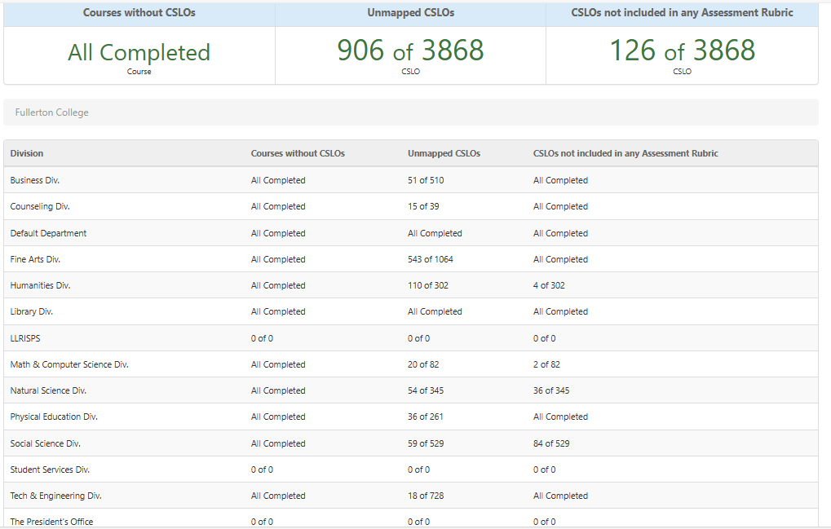

Figure 1

7. Review and comments on “SLOA Website” problem and issues
- There has been little progress on the SLOA Website review. The website is out of date and needs someone to update the site. There have been several email attempts to contact the Communication director, however it appears that the Communication Director position has been vacant for some time to my surprise. As I understand it a new Communication Director has been hired as of 2-7-25, hence I will attempt to contact them for some help. (41:55).
- One member asked a question regarding an email from someone asking for SLOA Committee member responsibilities. George Bonnand stated it was Bridget Kominek who sent the email and she wanted a listing of duties for the members. They were forwarded to her as of last month. (44:02)

8. Other-Issues, problems, reports
- No other issues or problems were reported.

9. Open training session on Elumen-After meeting.
- No training sessions were held after the meeting.

Meeting adjourned at 12:51PM

