|  |  |
| --- | --- |
|  | Fall 2024 SLOA Committee Meeting Agenda  Friday-December 6th , 2024-Noon- 1:00 PM (Room 904) Meeting called by George Bonnand, Chair Members: Caleb Petrie; Toni Nielson; George Bonnand; Deanna Smedley; Matthew Tribbe; Wendy Perez; Sean Sheil; Michael Mueller; Anna Shyrokova; Phat Truong; Karin Pavelek; Anastasia Nagel  Resources: José Ramón Núñez; Daniel Berumen |
|  |
|  |

**Agenda Items**

Assignment of Meeting Minutes Scribe

Approval of Agenda for today’s meeting (See below)-

|  |  |  |
| --- | --- | --- |
| **Topics** | Supporting Document Filename | Bring Copy |
| 1. Review and approval of proposed agenda for today (12-6-24). (see attachment) |  | No |
| 1. Review and approval of previous meeting minutes on 11-8-24 |  | No |
| 1. Assignment of Meeting Minutes Scribe (G. Bonnand) |  | No |
| 1. Elumen assessments for Fall 2024 |  | No |
| 1. Insights update |  | No |
| 1. Review and comments on “SLOA Website” problem and issues |  | No |
| 1. Other-Issues, problems, reports. |  | Yes as necessary |
| 1. Open training session on Elumen-After meeting. |  | Yes as necessary |

The following link is an video/audio recording of the SLOA meeting session on 12-6-24:

<https://fullcoll-edu.zoom.us/rec/share/JRPFiuNbbsj4MFQg4-281aySI_n0eHKz0je-BIMPTG1Jwq6eIlFDuZFHDyxFSOLh.6JvdIjtRFoZ05MHK?startTime=1733508541000>

Please find below a very brief summary of the meeting minutes for the in-person SLOA meeting on 12-6-24. This meeting was held in room 904 in building 900 at approximately noon. (Meeting minutes taken and written by George Bonnand).

The meeting started at approximately 12:08 PM on 12-6-24 in room 904 with the following members present:

* George Bonnand
* Michael Mueller
* Ana Nagel
* Caleb Petrie
* Mathew Tribbe
* Deanna Smedley
* Wendy Perez
* Phat Truong

Not present for this meeting are as follows:

• Toni Nielson

• Sean Sheild

• Karin Pavelek

• Anna Shyrokova

The following items were reviewed.

1. Review and approval of proposed agenda for today (12-6-24). (see attachment)

* All members present approved of the agenda for 12-6-24.

2. Review and approval of previous meeting minutes on 11-8-24

* All members present approved the minutes from the 11-8-24 meeting.

3. Assignment of Meeting Minutes Scribe (G. Bonnand)

* George Bonnand volunteered to take the Meeting Minutes for this meeting.

4. Elumen assessments for Fall 2024

* George Bonnand reviewed the stats chart for all divisions in Elumen (presentation on the screen via projection system-see below screen shot). A review of the “CSLOs not included in any Assessment Rubric” was presented to the SLOA team. All members are to be complimented on their efforts, especially Natural Science and Fine Arts. The Fine Arts division did obtain a “All Completed” status under the “CSLOs not include in any Assessment Rubric” heading which is a first since my tenure with this committee. The “963 of 3863 for Unmapped CSLOs” and the “201 of 3863 for CSLOs not included in any Assessment Rubric” are excellent numbers compared to previous years. Note: These numbers show the dedication of the SLOA team.

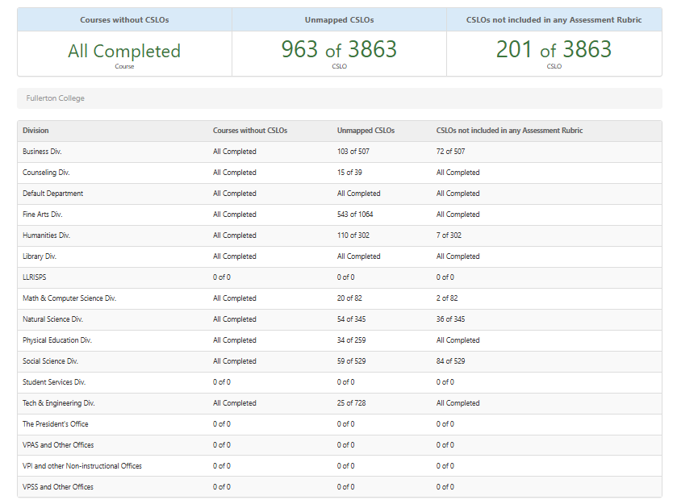

A general discussion among members was initiated and several questions were asked regarding how to make assessments and how to load assessments. Committee members were shown how to make assessments and load assessments for the next semester by George Bonnand using some courses from the Math Division.

A question was asked by Michael Mueller regarding whether there is a list provided that shows what courses have been reviewed by the Curriculum Committee so that members of SLOA team can be aware of changes to SLOs. George Bonnand stated that Guy Dadson can provide a report to members showing the courses that have had changes to SLOs. (14:28). George Bonnand showed the SLOA members how to check what current active CSLOs in CNET by using the CO icon for each active/approved course listed in Red.

Another question was asked by Caleb Petrie regarding “Unmapped CSLOs”. George Bonnand showed the SLOA members in Elumen how to determine which Course Student Learning Outcomes (CSLOs) are unmapped in each division/department. George Bonnand then showed the members how to map course CSLOs to Programs/Certificates Program Student Learning Outcomes (PSLOs) and how to map Program/Certificate PSLOs to the College Institutional Student Learning Outcomes (ISLOs). A general discussion regarding mapping of CSLOs and PSLOs ensued with questions from various members. It became apparent that mapping CSLOs to programs/certificates PSLOs may be a bit difficult for some departments that have crosslinking of their courses to various different department programs/certificate PLSOs. (Example: Math 131 F course which is linked to the Interdisciplinary Study AS degree). It is important to note that communication between SLOA members and SLOA members and faculty is important when mapping CSLOs to PSLOs and PSLOs to ISLOs. This process can be done readily over a quick zoom session with the various faculty disciplines for each course. Various scenarios of mapping for Math and Computer Science were shown on the projection screen using Elumen to the SLOA members. (26:30). Program/certificate PSLO mapping to ISLO and CSLO to PSLO mapping was also reviewed with SLOA members to answer any questions they may have.

5. Insights update

* George Bonnand stated that he had spoken with Elumen Insights today at 9AM. At this time we are on schedule with the implementation. George Bonnand stated that he needs to develop a power point for the faculty to show them how to link the rubrics (in Canvas) to the Insights (Elumen) CSLOs and PSLOs. George then asked SLOA members for their input on the following:
  + Should we develop a standard assessment rubric in Insights that can be loaded for each course (regardless of whether they use Canvas or not since all courses have a Canvas shell associated with it)? Or should we let the individual instructors attach the SLO in their specific rubric for each course? Or should we do both? The SLOA members seem to agree with doing both, however pilot testing would be necessary to determine if this is possible,

The following screen shots show a rubric in Canvas that has been created with CSLOs attached.

* + Another question for the group is whether we should turn this on in the Fall 2025 for everyone or should we do a “Pilot Test” of the Insights software with selected departments? The SLOA members seem to agree that a “Pilot Test” would be the best option for the implementation. With this said commitment from SLOA committee members would be necessary to do this pilot test.

1. Review and comments on “SLOA Website” problem and issues

* No update at this time. I have not heard back from the Campus Communications department regarding how to update this website.

1. Other-Issues, problems, reports.

* No other issues, problems, or reports were mentioned by the SLOA committee members.

1. Open training session on Elumen-After meeting.

* George Bonnand offered an open training session to SLOA committee members after the meeting. A few members took advantage of this opportunity to ask questions. Those that did not have enough time at the end of the meeting stated they would email me the questions.

Meeting adjourned at 12:50 PM. (44:50)

Special notes: Courses that are approved at the state level will show up in Red as active courses in CNET. Only active/approved courses in CNET (and their SLOs) should be used in Elumen or Insights. Also, only courses that are offered and scheduled in Banner will be shown in Elumen. Hence courses that are approved in CNET but never offered will not show up in Elumen because the courses are downloaded from Banner to Elumen.