Student Equity and Achievement (SEAC)
Committee Taskforce Meeting Minutes
Monday, September 18, 2023
3:00 p.m. – 4:30 p.m.
ZOOM: https://fullcoll-edu.zoom.us/j/89854533375

Members Present: Daniel Berumen, Cynthia Guardado, Jaime Perez, Juan Zaragoza, Marcia Foster, Arnetta Edwards, Bridget Salzameda, Cecilia Arriaza, Dani Wilson, Dolores Cornejo, Flor Huerta, Gilberto Valencia, Jorge Gamboa, Juan Zaragoza, Katheryn McGuthry, Kim Orlijian, Lugene Rosen, Mashonda Salsberry, Paul St. John, Connie Morena -Yamishiro, Rolando Sanabria
Members Absent:. Jill Kageyama, Chris Fernandez, Jessica Langlois, Monica Ernandes, Rachel Roschel, Grace Galaviz, Jennifer Merchant, Kristine Nikkhoo, Kennedy DeVries, Chloe Serrano, Rida Zar
Guests Present: Henry Hua, Anita Carlos, and Celina Gutierrez

Agenda Item | Action/Discussion | Comments
Announcements | Daniel Berumen called the meeting to order at 3:02 pm
- Review of Membership and Committee Charge | Daniel introduced:  -Paul St. John-Business CIS/Accounting was voted to become a member; Ming Ying Scott has been removed  -Rolando Sanabria representing student development/Counseling: 3-year, the term has expired.  -Jaime Perez-Fine Arts; Second year  -Cynthia Guardado: First-year, second term  -Lugene Rosen: First-year, Librarian  -Juan Zaragoza: The third year, will ask the division to select him again  -Marcia Foster: Second year  -Katheryn McGuthry: Second year, first term  -Jessica Langlois: Faculty rep; TBD  -Arnetta Edwards (counseling): Second year  -Flor Huerta: First term, second year: will send an email to faculty members who would be interested in the counseling faculty rep.  -Connie, Kim, Kristine, Jorge, Cecilia, Bridget, Dani Wilson  Classified Staff Reps Introductions:  - Gilberto: second term, third-year  -Monica Ernandes: TBD  -Dolores Cornejo: First term, Second year.  -Grace Galaviz: TBD  NON-VOTING Members:  Connie Moreno-Yamashiro  Cynthia Guardado  Jennifer Merchant  Mashonda Salsberry | -Rolando confirmed expiration as a committee member  -Cynthia confirmed his term has expired and to discuss his replacement.  -Lisa Macafee left the college  -No Natural Science faculty selected  -Members confirmed Lisa is not at Fullerton College.  -Daniel reminded the members that Dr. Olivo has appointed managers to be appointed on SEAC.  - Co-chairs responded that UMOJA is a resource member of the committee. Discussion to make UMOJA a voting member position however they are working on the details. Co-chairs reminded Mashonda that UMOJA is important to the committee and made introductions.
Approval of Minutes | Minutes approved by members | Cecilia-Kyari’s last name is misspelled. Correction made.
Public Comments | Henry Hua, Celina Gutierrez, and Anita Carlos: SEA Budget Update
Member Announcements | HAPPY BIRTHDAY CYNTHIA!
Review of Key 2023-2025 SEA Plans | Co-Chairs presented the 2023-2025 SEA plans.  - A slide presentation was shown: A quick refresher of what the campus committees are working on and defining terms based on equity and equality.  - Fullerton College Campus Metrics/Data:  -Enrollment  -Completion of transfer math/English  -First-time students  -Mission goal completion  -Transfers  - The writing group suggests targeting the gaps between Black and Latino Students and closing them.  Co-Chairs opened the discussion to members: No other questions | -(Lugene) The presentation will be sent to committee members. (Kesha)  -The co-chair detailed a huge gap between Black and Latino students. (Disaggregated Data)
SEA Budget Update | Budget of the SEA Plan  1. Co-chairs opened the floor to Henry Hua and Anita Carlos  -Clarifying budgets for the C plan  -Budget figures are preliminary  -Money disbursed from the State Chancellor’s office disbursed annually  -Waiting for the district to give calculations that will be distributed to Fullerton College  -A spreadsheet of the budget amounts was presented from 2021-2023  -Presented the allocation for 2023-2024  -Where should the money go into different programs and how the money can be utilized  -Member suggested to add Umoja  -Henry proposed meeting with SEAC once a month, giving a breakdown of expenditure usage  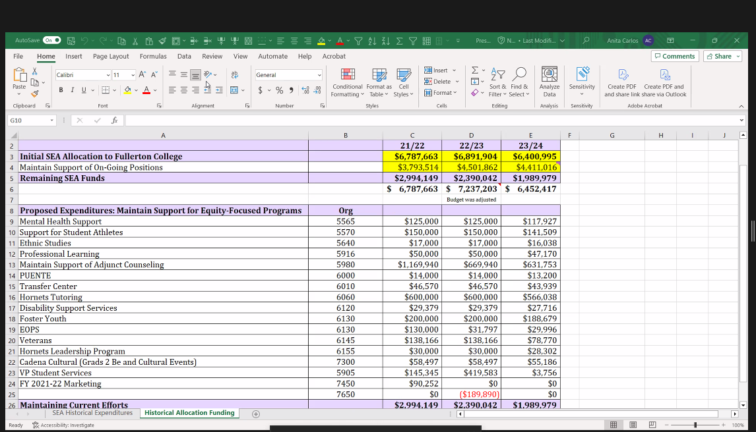 | -The Co-chair needed clarification on cell D4. Why did costs go down? The question was clarified by Henry. (moved some permanent positions)  -A committee member was asked to follow up with Henry and Anita regarding activity codes, accounted and not accounted for. Also, to inquire regarding the funding for Black and Latino students and how to best allocate and reallocate the funding. Is there a possibility for Umoja to receive any C funds for 23/24? -Co-chair the money budgeted will not be allocated to Umoja this year.  -Members requested some clarification regarding the budget to determine dollar amounts, positions, funding decreases, overages, and a problem with UMOJA not being on the list to allocate funding through C.  -The co-chair acknowledged members' concerns and requested to think of a solution that would assist with allocating funds.  -Member asked if programs have been informed of the new allocations for this year.  -Member stated that the majority of the programs are supported through general funds. Concerned that Latino and Black students are not included. (Umoja and A2Mend)  -Member proposed that it might be helpful to remind the committee how specific dollar amounts were determined and how it got rolled over to 23/24. How did the funding decrease over time having critical conversations and leaning heavily on the C plan instead of starting a new one?  The co-chair conveyed the history of the committee and how funds were locked in for this budget plan. (C task force) Proposed that recommendations need to be reviewed and if they are applicable to the budget presented today.  -Member stated the programs not knowing where their funds have been placed is concerning and disheartening.  - Member had concerns regarding Umoja: Reevaluate the budget with the growth of Black and AA students. Come up with a solution to assist our Black students on campus. How much data can be shared to shift allocation to support Black students?  The co-chair conveyed the budget was being developed without planning. Merged multiple funding streams together however, the goal was to bring this to the committee to discuss first.  -A solution would be to show how the dollars, relate and support the metrics of the DEI Groups to PAC and Faculty Senate. C dollars need to be aligned with the plan.  -Member had a question regarding section 23 amount budgeted was significantly high in 21/22, however, there was a decrease (23/24) that is concerning.  -Henry conveyed it was allocated and items were cut; Anita confirmed.  -Member had a question regarding salaries and if they are budgeted through the district or the C budget. Concerns for reclassification and how that money will decrease the money allocated.  -Confirmed it will be allocated through the C budget, not the district.  -Member needed clarity on their funding and what they were used for.  -Henry will assist with her question  The co-chair proposed a debrief regarding the SEA expenditures budget at the next meeting.  -Members agreed.
Meeting adjourned | The meeting was adjourned at 4:27 pm

