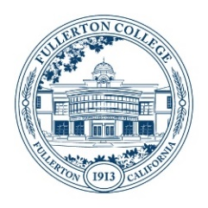
Student Equity and Achievement (SEA)
Committee Meeting Agenda
Monday, December 4, 2023
3:00 – 4:30 p.m.
ZOOM:
https://fullcoll-edu.zoom.us/j/89854533375
Co-Chairs: Cynthia Guardado, Daniel Javier Berumen

AGENDA
HOUSEKEEPING
- Call to Order All
- Agenda All
- Approval of Notes All
  - 11/13/23 Meeting
  - 11/27/23 Meeting
- Public Comment All
- Announcements All

OLD BUSINESS
- Reflection/Feedback Form for Funded Programs Daniel

NEW BUSINESS
- SEA Co-Chair Proposal – Discussion and Possible Vote Daniel

OTHER TOPICS FOR DISCUSSION
- Other Topics All
- Adjournment

NEXT MEETING: Monday, February 5th, 2024 @ 3pm

