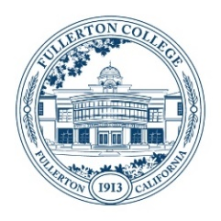
Student Equity and Achievement (SEA)
Committee Meeting Agenda
Monday, November 27, 2023
3:00 – 4:30 p.m.
ZOOM:
https://fullcoll-edu.zoom.us/j/89854533375
Co-Chairs: Cynthia Guardado, Daniel Javier Berumen

AGENDA
HOUSEKEEPING
- Call to Order All
- Agenda All
- Approval of Notes All
  - 10/16/23 Meeting
- Public Comment All
- Announcements All

OLD BUSINESS
- Reflection/Feedback Form for Funded Programs Daniel

NEW BUSINESS
- SEA Co-Chair Proposal – Discussion (No Vote) Daniel
- CCCCO’s Diversity, Equity, Inclusion, and Accessibility Glossary of Terms Daniel
- RP Group: African American Transfer Tipping Point Study (Informational) Daniel
- Integrated Planning Workgroup Proposal (Informational) Daniel

OTHER TOPICS FOR DISCUSSION
- Other Topics All
- Adjournment

NEXT MEETING: Monday, December 4th, 2023 @ 3pm

