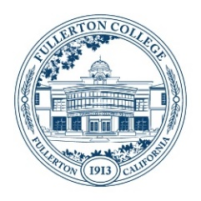
Student Equity and Achievement (SEA)
Committee Meeting Agenda
Monday, October 16, 2023
3:00 – 4:30 p.m.
ZOOM:
https://fullcoll-edu.zoom.us/j/89854533375
Co-Chairs: Cynthia Guardado, Daniel Javier Berumen

AGENDA
HOUSEKEEPING
- Call to Order All
- Agenda All
- Approval of Notes All
  - October 2, 2023
- Public Comment All
- Announcements All

NEW BUSINESS (Discussion with Possible Action)
- Group Discussion on SEA Plan Cynthia
- Identifying Workgroups Cynthia
- Inviting Stakeholders to Share/Present at SEA Daniel
- Reflection/Feedback Form for Funded Programs Daniel
OTHER TOPICS FOR DISCUSSION
- Other Topics All
- Adjournment

NEXT MEETING: Monday, October 16, 2023 @ 3pm

