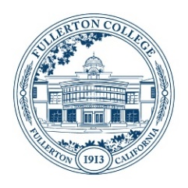
Student Equity and Achievement (SEA)
Committee Meeting Agenda
Monday, October 2, 2023
3:00 – 4:30 p.m.
ZOOM:
https://fullcoll-edu.zoom.us/j/89854533375
Co-Chairs: Cynthia Guardado, Daniel Javier Berumen

AGENDA
HOUSEKEEPING
- Call to Order All
- Agenda All
- Approval of Notes All
  - September 18, 2023
- Public Comment All
- Announcements All

OLD BUSINESS (Discussion with Possible Action)
- SEA Budget Update – Final Items Daniel/Cynthia

NEW BUSINESS (Discussion with Possible Action)
- SEA Budget: Ideas for Moving Forward Cynthia/Daniel
- SEA Activity Codes Update Daniel

OTHER TOPICS FOR DISCUSSION
- Other Topics All
- Adjournment

NEXT MEETING: Monday, October 16, 2023 @ 3pm

