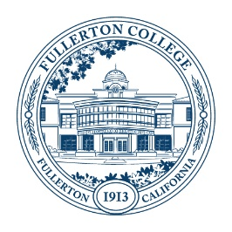

Fullerton College Program Review and Planning Committee

Readers’ Report on Annual Update, Fall 2022

Program Name:
Thank you for submitting your annual update. The Program Review Committee Readers’ Report is a way for the Committee to provide feedback. This form endorses your requests for resources, which is one step in the College budget process. Please read the comments below for the Committee’s specific suggestions and questions. If you wish to respond to this form then please do so in the response section below.

Annual update section | Completed |  | Not Completed
Part I: Review of Data | X
 | Exceeds expectations | Meets expectations | Provisional, needs improvement | Does not meet expectations
Part II: Additional Resource Request Reasoning and Support |  | X
Part III: Resource Request Funding |  | X

Committee comments
Thank you for submitting this self-study. The three requests—for a sports club/intramuals director, kinesiology recruiter, and instructor hiring for dual enrollment classes—are supported in the sections that ask for additional information. The questions associated with the resource requests are not answered directly in the sections where the questions are asked. For additional faculty for dual enrollment, a faculty member would be most appropriate as dual enrollment classes are Fullerton College classes taught by FC faculty at local high schools.

Optional program response
[This section is optional. Please respond if you would like to give the Committee additional information or clarification.]

Signatures
Bridget Kominek and Mary Bogan, Program Review and Planning Committee Co-Chairs Date: 4/14/23

