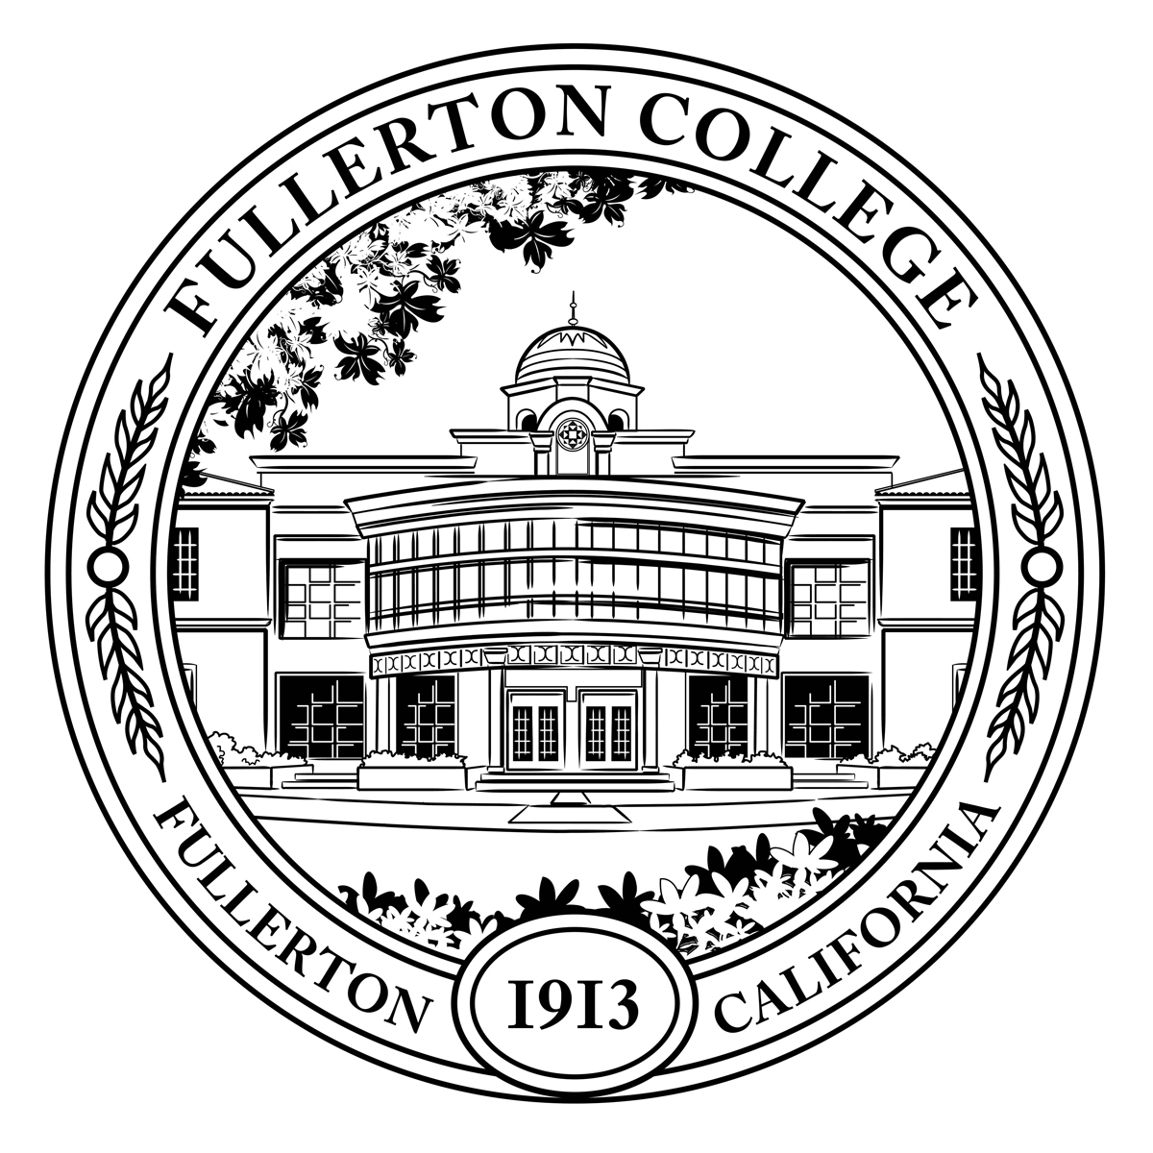
Institutional Integrity Committee
Agenda

Co-Chairs: Daniel Berumen Members: Alex Brown, Roman de Jesus, Marcia Foster, Michael Gieck, David Grossman, JP Gonzalez, Jennifer Merchant, Jeanette Rodriguez, Kesha Shadwick
Student Representative: N/A
Resource Member: Danielle Fouquette

Zoom ONLY: https://fullcoll-edu.zoom.us/j/86181813393

HOUSEKEEPING

Daniel called the meeting to order at 304pm.
- Call to Order
- Agenda All
- Approval of Notes : The notes for 11/14/2023 were approved. All
- Public Comment All
- Announcements All

OLD BUSINESS (Discussion with Possible Action)
- IPWG Proposal Update Daniel Berumen
- Mission Statement Update Daniel Berumen
- IIC’s Role in the Annual Program Review Update Process Daniel Berumen

NEW BUSINESS (Discussion with Possible Action)
- Institutional Student Learning Outcomes Preview Daniel Berumen

OTHER TOPICS FOR DISCUSSION
- Other Topics All
- Adjournment

NEXT MEETING: Tuesday, February 13, 2024 @ 1pm
Agenda and Minutes: Cynthia Olivo, Gilbert Contreras, Jean Foster, Nitzya Hamblet, Melisa McLellan, José Ramón Núñez, Ron Farrol

