Honors Advisory Committee
Notes
October 17, 2023

Attended:
Hannah Hernandez, AS Representative
Tim Ream, Librarian
Naveen Kanal, Golf Coach
Ana Tovar, Honors Counselor
Citlally Santana, Honors Counselor
Jodi Balma, Honors Coordinator

Transfer/Certification Updates
- Fall Transfer Plans Survey Canvas – November 30
  - See Below for preliminary responses
- Honors Certification forms on Canvas
  - UCLA/UCI Deadline early Feb
  - General - Deadline end of March
- STEM Certification – Extracurricular Activities
2023 STEM Events Master list.docx - Google Docs
Discussion:
Honors Certification Event – with Transfer Center?
In years past, we’ve held a separate lunch celebration for Honors Certified Students. Last year, we combined with the Transfer Celebration which was a great event. There was a sense that it worked well, and we should continue to combine events.
New Honors Classes
We met with faculty from Communications. Both public speaking and forensics classes will be developed for honors. Any other departments that would like to develop new curriculum for honors can meet with Jodi Balma, Honors Coordinator with any questions.
Honors Updates:
- Winter/Spring 2024 Classes
- Recruiting Efforts
  - New Honors Alumni Poster Series
  - Golden Ticket for Faculty/Counselor Recommendations
  - President’s/Dean’s List Invitation
- 31 New Honors Ambassadors
  - College Fairs
  - Outreach Events
  - Social Media

Fall Transfer Survey (due November 30)
36 responses so far
25 Submitted UC TAG
- Irvine (15)
- Santa Barbara (7)
- Santa Cruz (2)
- Davis (1)
- Merced (1)
- Riverside (1)
25 plan to be Honors Certified by spring 2024
19 UCLA TAP Certified
13 UCI Honors to Honors
UC Applications
25 UC Irvine
25 UCLA
19 UC Berkeley
17 San Diego
15 Santa Barbara
8 Davis
6 Riverside
6 Santa Cruz
1 Merced

CSU Applications
17 CSU Fullerton
10 CSU Long Beach
7 Cal Poly Pomona
4 CSU Los Angeles
4 CSU San Diego
3 CSU Northridge
3 CSU San Francisco
3 CSU San Jose
2 CSU Monterey Bay
1 CSU East Bay
1 Cal Poly Humboldt
1 CSU Sacramento
1 CSU San Bernardino
1 CSU San Marcos

Jack Kent Cooke Undergraduate Transfer Scholarship
31 will research and consider
21 have AP Units
11 have college credits from other colleges

Recruiting
New Honors Alumni Transfer Poster Series

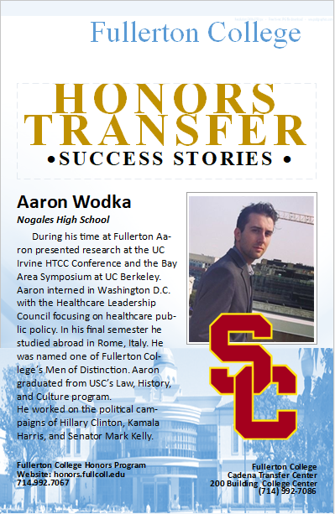

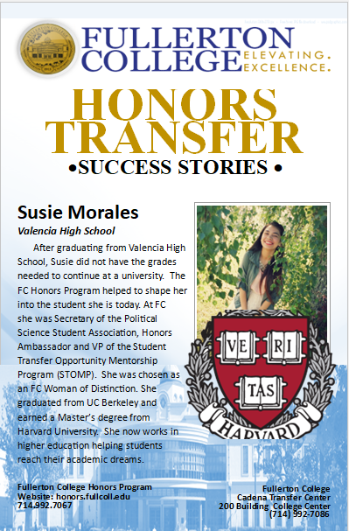

Golden Ticket: Faculty/Counselor Recommendations
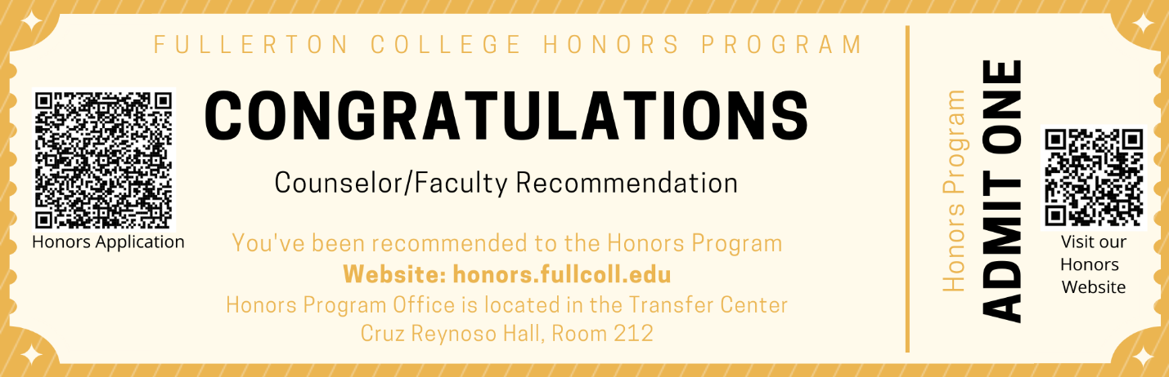

HTCC Research Conference
December 1st Deadline for abstract applications
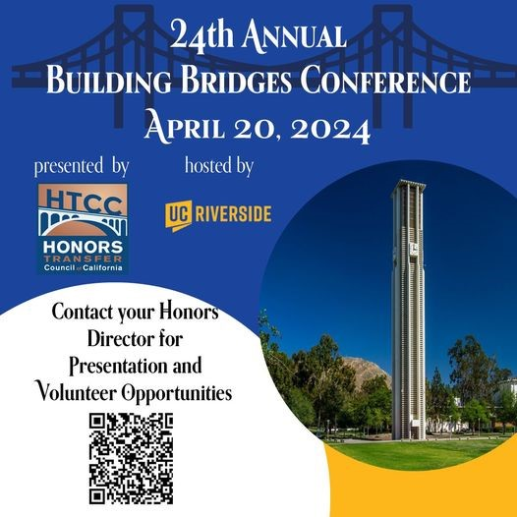

Winter/Spring Honors Classes

Winter 2023
- ANTH 101 HF Honors Physical Anthropology Online Professor Cadena (3 units)
- LIB 101 HF Honors Intro to Research Professor Rosen (1 unit)
Spring 2024 Honors Classes

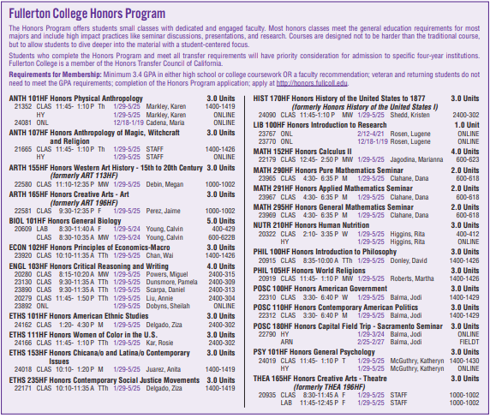

Follow Up Items:
Emailed Deniz Fierro about Promise students having winter session units covered. Units taken in winter do not count towards the Promise 12-unit spring 2024 requirement.

Emailed Rena Martinez-Stluka and Albert Abutin, Admissions and Records to find out where/how to direct students who need to exceed the 19-unit limit for winter/spring.
Response from Rena:
Students can come to A&R in person or join our remote services (A&R zoom room) for assistance with increasing their max units due to taking Winter Intersession courses.
A&R Hours & Services | Admissions and Records (fullcoll.edu)

